President University



Report of Programming Assignment XXIII

Hitbox Detection

Computer Graphics and Animations

Nikita Chrissandha M (001201500031)

Predrika Br Ginting (001201500032)

Teuku Hilman Revanda (001201500038)

CIT 2 2015

2D Computer Graphics and Animation is a subject on Semester 7th of Information Technology lectured by Mr. Eddo Fajar Nugroho, S.Kom, MT.

# Introduction

Almost every video game needs to respond to objects touching each other in some sense, a practice commonly known as collision detection. Collision detection is a mechanism whether two objects collide. There are many algorithms for detecting collision. In this programming assignment, we’ll be using hit area detection or hitbox detection.

A hitbox is an invisible shape commonly used for real-time collision detection. Hitboxes are used to detect “one-way” collisions such as hit by a punch or bullet. It is common for animated objects to have a hitbox or a set of hitboxes attached to one moving part each to ensure accuracy during motion.

In this programming assignment, the developers use Visual Bacis. The developers create an application that simulates a fighter hitting coming objects. The developers create their own procedure of putting a sprite on a background and hitbox detection.

# Basic Theory

## Sprite Animation

Sprite animation have been used in games for a long time. Back in 1872, Eadweard Muybridge was commissioned to prove whether a horsse lifted all four legs off the ground at once when it ran. To do so, he set up a series of cameras along a track and took pictures in quick succession as a house ran by. This process allowed him to capture 16 pictures of the horse’s run. In one of the pictures, the horse did indeed have all four legs off the ground.

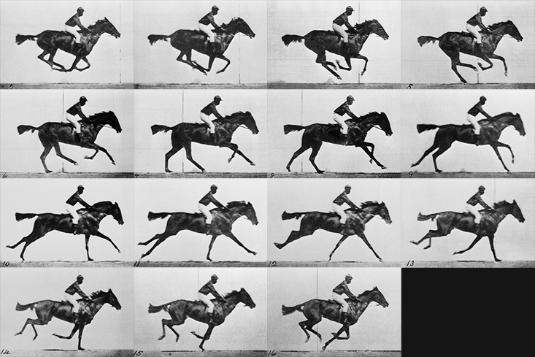

Muybridge placed each photo onto a device that could project the photos in rapid succession to give the illusion of the horse running. The process of changing images in quick succession to give the illusion of movement is called animation.

In computer graphics, a sprite is a two-dimensional bitmap that is integrated into a large scene so that it appears to be part of the scene. Sprites are a popular way to create large, complex scenes as you can manipulate each sprite separately from the rest of the scene. This allows for greater control over how the scene is rendered, as well as over how the players can interact with the scene.

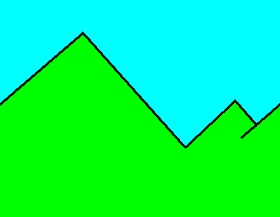A game interface can consist of several background layers and several sprite layers. Sprites animation were orginally inverted as a method of quickly compositing several images together in two-dimensional video games. A sprite can’t be put directly on a background. This is what happen if a sprite put directly on the background.

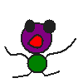

So, there are some steps to put a sprite on a background. First, create a “mask” of the sprite. A mask is a black contour of the sprite on a white background. The sprite itself should be changed to have a black background. Here is the example of the mask and the sprite.

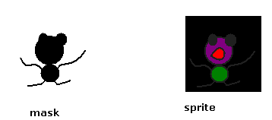

After the mask is created, perform an AND operation between the background and the mask. If there are any color on background perform an AND operation with black colour, it will be black.

***any color AND black = black***

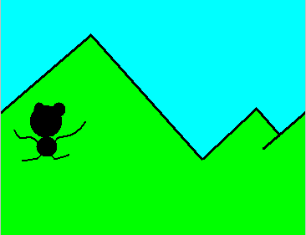

Then, perform an OR operation between the background and the sprite. If the sprite color is any color perform OR operation with black color, the color of the sprite will be the same like before (nothing change).

***any color OR black = that color***

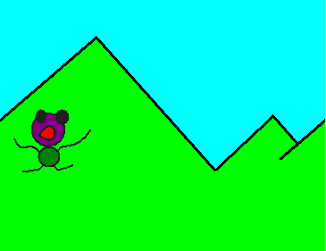

## Hitbox detection

Almost every video game needs to respond to objects touching each other in some sense, a practice commonly known as collision detection. Collision detection is the computational problem of detecting the intersection of two or more objects or a mechanism to detect whether two objects collide. There are plenty of ways to do collision detection. The methods for collision detection that is used in this programming assignment is hit area detection. Actually, there are two kinds of area that can be used in this method, circular and rectangular, but this program only use rectangular, so the method can be called as hitbox detection. This method is ideal for smaller objects that are roughly rectangilar and because it is incredibly fast to process. It will be described uses a contradiction to determine whether the rectangles intersect. Rectangles will be defined by their left, top, bottom, right edges.

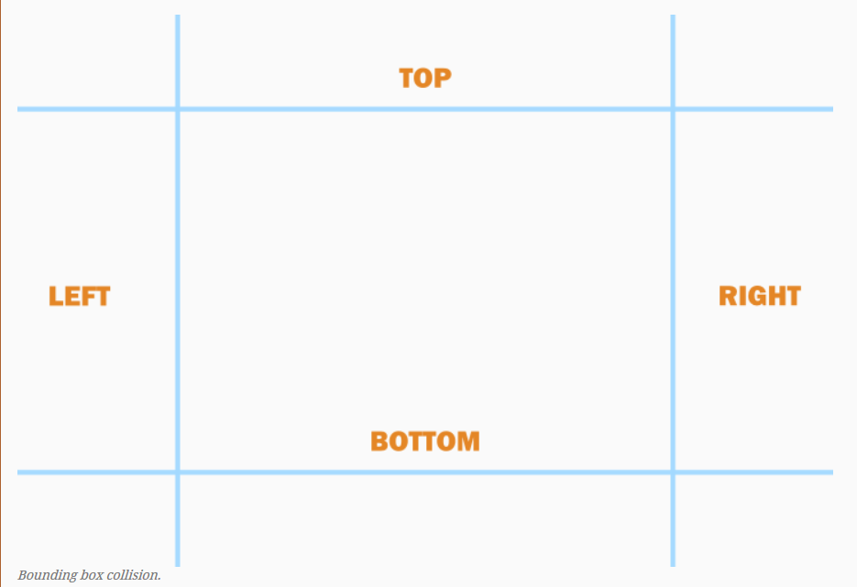

To determine whether two rectangles do not intersect, one simply has to check for any of the following conditions:

* Rectangle 1’s bottom edge is higher than Rectangle 2’s top edge.
* Rectangle 1’s top edge is lower than Rectangle 2’s bottom edge.
* Rectangle 1’s left edge is to the right of Rectangle 2’s right edge.
* Rectangle 1’s right edge is to the left of Rectangle 2’s left edge.

## Sprite Transition Diagram

**Attack**

**Walk   
Left**

**Intro**

**Hadouken**

**Jump**

**Death**

**Walk   
Right**

**Stand**

**Fall Down**

**Jump  
Forward  
Left**

**Crouch  
Right**

**Crouch**

**Jump  
Forward  
Right**

**Crouch  
Left**

# Features in the Program

There are several features on this game. These features are listed below.

## Walks to Left Side

If the user press A or Left Arrow button on the keyboard, Ryu will walk to left side.

## Walks to Right Side

If the user press D or Right Arrow button on the keyboard, Ryu will walk to left side.

## Jumps

If the user press W or Up Arrow button on the keyboard, Ryu will jump.

## Crouches

If the user press S or Down Arrow button on the keyboard, Ryu will crouch.

## Jumps Forward Facing Left Side

If the user press Q or Shift button on keyboard, Ryu will jump forward to the left side.

## Jumps Forward Facing Right Side

If the user press E or End button on keyboard, Ryu will jump forward to the right side.

## Punches

If the user press Tab button on the keyboard while Ryu, Ryu will be punching. It could be a punching while standing, crouching or jumping.

## Hadouken

If the user press Caps Lock button on the keyboard while Ryu is standing, Ryu will perform hadouken.

## Attacked (Death)

If Ryu get attacked by the obstacle, then Ryu will be dead.

## Game over

When Ryu is dead, the game will be over.

## Replay

At game over, user could choose to play again,

## Win

If Ryu doesn’t get any hit from obstacle then the user will win.

# The Background and Sprites Used in the Program

## Background

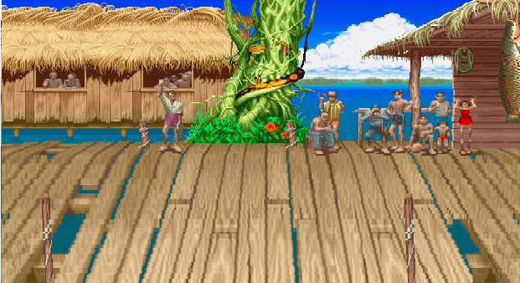Image that is used as background in this program is as follow.

## Sprites

### Introduction

These are sprites of introduction.

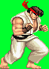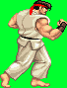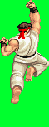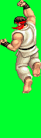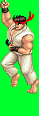

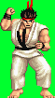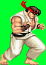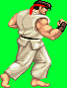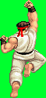

### Ryu Stands Facing Right Side

These are sprites of Ryu standing facing right side.

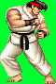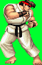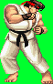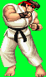

### Ryu Stands Facing Left Side

These are sprites of Ryu standing facing left side.

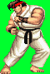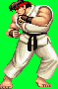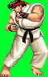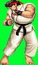

### Ryu Crouches Facing Right Side

These are sprites of Ryu crouching facing right side.

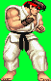

### Ryu Crouches Facing Left Side

These are sprites of Ryu crouching facing left side.

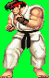

### Ryu Jumps Facing Right Side

These are sprites of Ryu jumping facing right side.

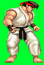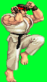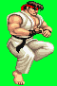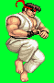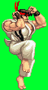

### Ryu Jumps Facing Left Side

These are sprites of Ryu jumping facing left Side.

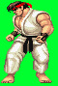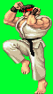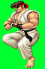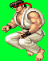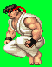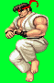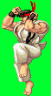

### Jumps Forward Facing Right Side

These are sprites of Ryu jumping forward facing right side.

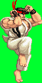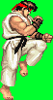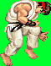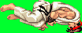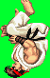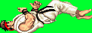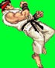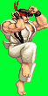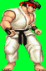

### Jumps Forward Facing Left Side

These are sprites of Ryu jumping forward facing left side.

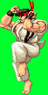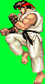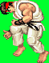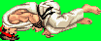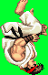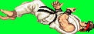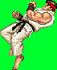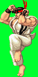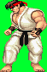

### Ryu Performs Hadouken to Right Side

These are sprites of Ryu performing hadouken to right side.

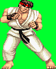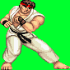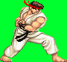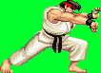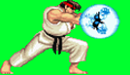

### Ryu Performs Hadouken to Left Side

These are sprites of Ryu performing hadouken to left side.

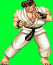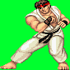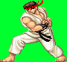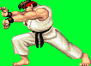 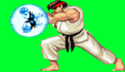

### Punches Facing Right Side

These are sprites of Ryu punching facing right side.

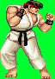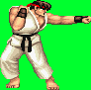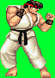

### Punches Facing Left Side

These are sprites of Ryu punching facing left side.

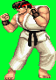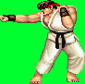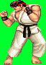

### Kicks While Jumps Facing Right Side

These are sprites of Ryu kicking while jumping facing right side.

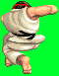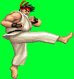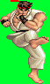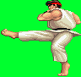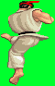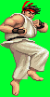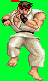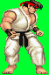

### Kicks While Jumps Facing Left Side

These are sprites of Ryu kicking while jumping facing left side.

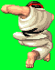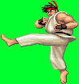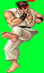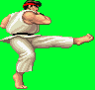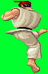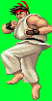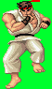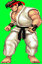

### Punches While Crouches Facing Right Side

These are sprites of Ryu punching while crouching facing right side.

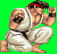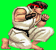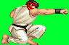

### Punches While Crouches Facing Left Side

These are sprites of Ryu punching while crouching facing left side.

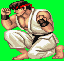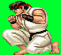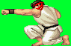

### Wins

These are sprites of Ryu winning.

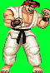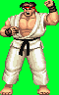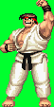

### The death of Ryu Facing Right Side

These are sprites of the of Ryu facing right side.

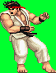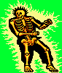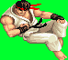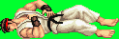

### The death of Ryu Facing Left Side

These are sprites of the death of Ryu facing left side.

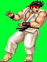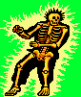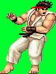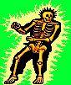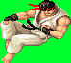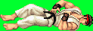

### Hadouken Fire Ball Facing Right Side

These are sprites of hadouken fire ball being thrown by Ryu facing right side.



### Hadouken Fire Ball Facing Left Side

These are sprites of hadouken fire ball being thrown by Ryu facing left side.



### Obstacle(Bee) Facing Left Side

These are sprites of obstacle (Bee) facing left side.



### Obstacle(Bee) Facing Right Side

These are sprites of obstacle (Bee) facing right side.



### The Death of Obstacle(Bee) Facing Right Side

These are sprites of obstacle being attacked by Ryu facing right side.

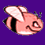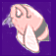

### The Death of Obstacle(Bee) Facing Left Side

These are sprites of obstacle being attacked by Ryu facing left side.

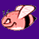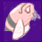

### Game Over

These are sprite of game over screen.

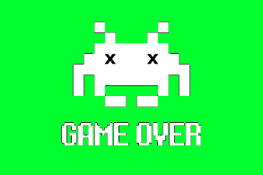

# The Actions for the Fighter Defined in the Program

There are several actions that can be done by Ryu. This are the variable defined for the action

## Walks to Left Side

This is the code for Ryu to walk to the left side.

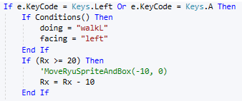

If the user press A or Left Arrow button on the keyboard, Ryu will walk to left side.

## Walks to Right Side

This is the code for Ryu to walk to the right side.

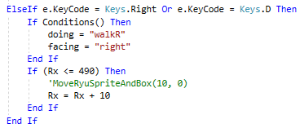

If the user press D or Right Arrow button on the keyboard, Ryu will walk to left side.

## Jumps

This is the code for Ryu to jump.

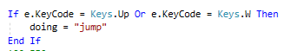

If the user press W or Up Arrow button on the keyboard, Ryu will jump.

## Crouches

This is the code for Ryu to crouch.

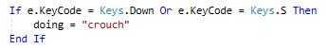

If the user press S or Down Arrow button on the keyboard, Ryu will crouch.

## Jumps Forward Facing Left Side

This is the code for Ryu to jumps forward to left side.

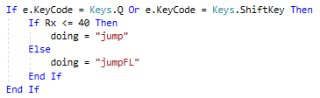

If the user press Q or Shift button on keyboard, Ryu will jump forward to the left side.

## Jumps Forward Facing Right Side

This is the code for Ryu to stands.

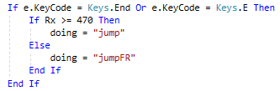

If the user press E or End button on keyboard, Ryu will jump forward to the right side.

## Punches

This is the code for Ryu to punch while standing.

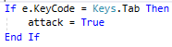

If the user press Tab button on the keyboard while Ryu, Ryu will be punching. It could be a punching while standing, crouching or jumping.

## Hadouken

This is the code for Ryu to perform hadouken.

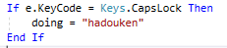

If the user press CapsLock button on the keyboard while Ryu is standing, Ryu will perform hadouken.

# The Background and Sprites Represented in the Program

The background and sprites are added to resources. To combine the background and the sprite, the following code is used.



In this code, function PutSprite is called and the parameters are bg, Ryu, Rx, Ry. This is what the function contained.

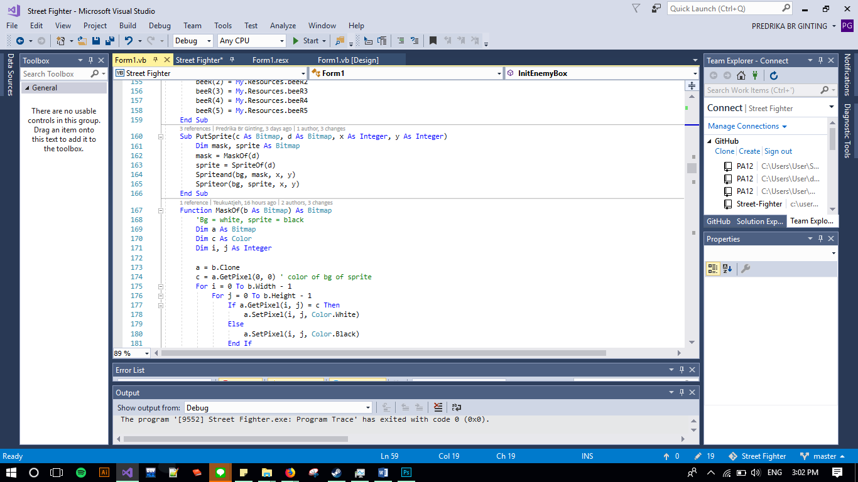

PutSprite function calls other functions which are MaskOf(d), SpriteOf(d), Spriteand(bg,mask,x,y), and Spriteor(bg,sprite,x,y).

* The MaskOf(d) function contains the following codes.

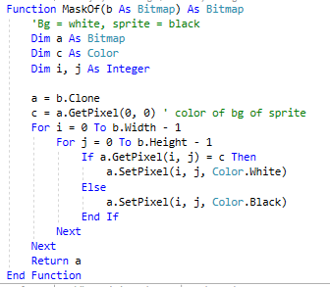

The MaskOf(d) is for manipulate the sprite background to be white and the sprite itself to be black.

* The SpriteOf(d) contains the following codes.

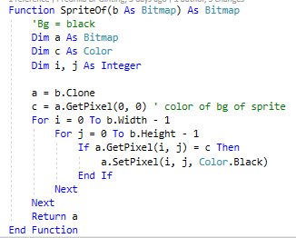

The SpriteOf(d) is to manipulate the background of the sprite to be black.

* The Spriteand(bg,mask,x,y) contains the following codes.

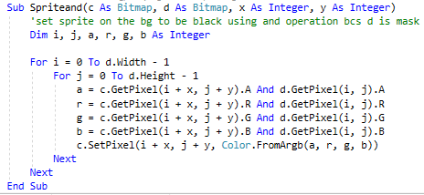

The Spriteand(bg,mask,x,y) is to combine the background and the sprite using ‘and’ operation. This method resulting on the mask to be on top of the background.

* The Spriteor(bg,sprite,x,y) contains the following codes.

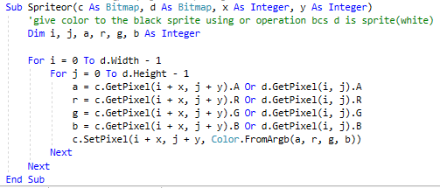

This method is to combine the previously edited combined background with the the result of SpriteOf() using ‘or’ operation. As this is the last step, this resulting on the sprite totally shown on the background without any attached background of the sprite.

# The Actions and Animations of the Sprites Represented in the Program

## Introduction

This is the code for introduction by Ryu.

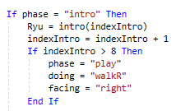

When the phase is “intro”, set of images that will be put on the background is intro images. After all images are shown, the phase will be changed to be “play”, doing changed to be “walkR”, and facing changed to be “right”.

## Stands Facing Left Side

This is the code for Ryu to stand facing left side.

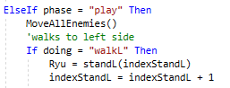

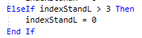

When the phase is play, set of images that will be put on the background is StandL. Because there are only 3 images of StandL, when indexStandL is greater than 3, indexStandL is set to be 0.

## Stands Facing Right Side

This is the code for Ryu to stand facing right side.

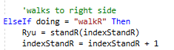

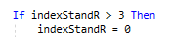

When the phase is play, set of images that will be put on the background is StandR. Because there are only 4 images of StandR, when indexStandR is greater than 3, indexStandR is set to be 0.

## Punches While Standing Facing Left Side

This is the code for Ryu to punch while standing facing left side.

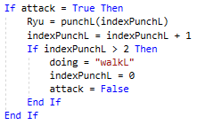

When the attack is true, set of images that will be put on the background is punchL. Because there are only 3 images of punchL, when index indexPunchL is greater than 2, indexPunchL is set to be 0.

## Punches While Standing Facing Right Side

This is the code for Ryu to punch while standing facing right side.

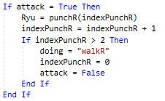

When the attack is true, set of images that will be put on the background is punchR. Because there are only 3 images of punchR, when index indexPunchR is greater than 2, indexPunchR is set to be 0.

## Crouches Facing Left Side

This is the code for Ryu to crouch facing left side.

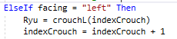

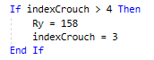

For Ryu to crouches facing left side, the set of images that will be put on the background is crouchL. Because there are only 5 images of crouchL, when indexCrouchL is greater than 4, indexCrouchL is set to be 0.

## Crouches Facing Right Side

This is the code for Ryu to crouch facing right side.

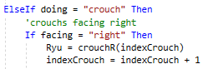



For Ryu to crouches facing right side, the set of images that will be put on the background is crouchR. Because there are only 4 images of crouchR, when indexCrouchR is greater than 3, indexCrouchR is set to be 0.

## Punches While Crouching Facing Left Side

This is the code for Ryu to punch while crouching facing left side.

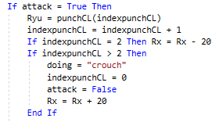

When the attack is true, set of images that will be put on the background is punchCL. Because there are only 3 images of punchCL, when index indexPunchCL is greater than 2, indexPunchCL is set to be 0.

## Punches While Crouching Facing Right Side

This is the code for Ryu to punch while standing facing right side.

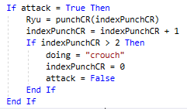

When the attack is true, set of images that will be put on the background is punchCR. Because there are only 3 images of punchCR, when index indexPunchCR is greater than 2, indexPunchCR is set to be 0.

## Jumps Facing Left Side

This is the code for Ryu to jump facing left side.

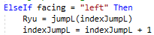

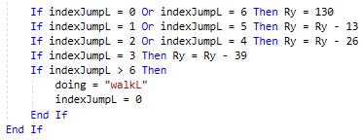

For Ryu to jump facing left side, the set of images that will be put on the background is jumpL. Because there are only 7 images of jumpL, when indexJumpL is greater than 6, indexJumpL is set to be 0.

## Jumps Facing Right Side

This is the code for Ryu to jump facing right side.

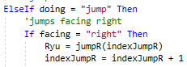

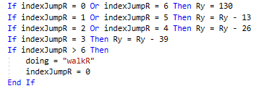

For Ryu to jump facing right side, the set of images that will be put on the background is jumpR. Because there are only 7 images of jumpR, when indexJumpR is greater than 6, indexJumpR is set to be 0.

## Kicks While Jumping Facing Left Side

This is the code for Ryu to punch while crouching facing left side.

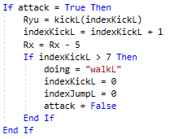

When the attack is true, set of images that will be put on the background is kickL. Because there are only 8 images of kickL, when index indexKickL is greater than 7, indexKickL is set to be 0.

## Kicks While Jumping Facing Right Side

This is the code for Ryu to punch while standing facing right side.

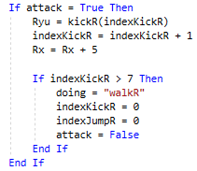

When the attack is true, set of images that will be put on the background is kickR. Because there are only 8 images of kickR, when index indexkickR is greater than 7, indexkickR is set to be 0.

## Jumps Forward Facing Left Side

This is the code for Ryu to jump forward facing left side.

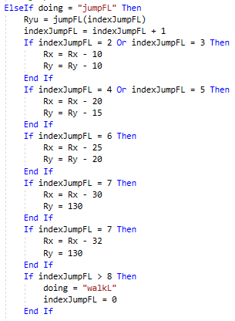

For Ryu to jump forward facing left side, the set of images that will be put on the background is jumpFL. Because there are only 9 images of jumpFL, when indexJumpFL is greater than 8, indexJumpFL is set to be 0.

## Jumps Facing Right Side

This is the code for Ryu to jump forward facing right side.

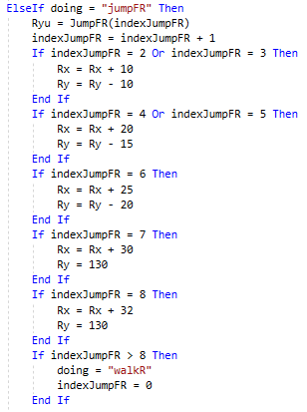

For Ryu to jump forward facing right side, the set of images that will be put on the background is jumpFR. Because there are only 9 images of jumpFR, when indexjumpFR is greater than 8, indexJumpFR is set to be 0.

## Performs Hadouken Facing Left Side

This is the code for Ryu to perform facing left side.

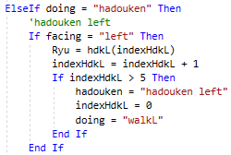

For Ryu to perform hadouken facing left side, the set of images that will be put on the background is hdkL. Because there are only 6 images of hdkL, when indexHdkL is greater than 5, indexHdkL is set to be 0.

## Performs Hadouken Facing Right Side

This is the code for Ryu to performs hadouken facing right side.

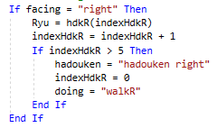

For Ryu to perform hadouken facing right side, the set of images that will be put on the background is hdkR. Because there are only 6 images of hdkR, when indexHdkR is greater than 5, indexHdkR is set to be 0.

## Moving Fireball to Left Side

This is the code for the fireball to move to left side.

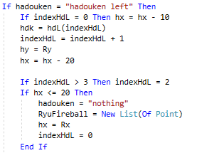

When hadouken is hadouken Left, set of images that will be put on the background is hdL. Because there are only 4 images of hdL, when index indexHdL is greater than 3, indexHdL is set to be 0.

## Moving Fireball to Right Side

This is the code for fireball to move to right side.

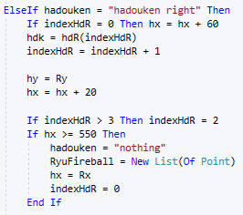

When hadouken is hadouken Right, set of images that will be put on the background is hdR. Because there are only 4 images of hdR, when index indexhdR is greater than 3, indexhdR is set to be 0.

## Moving Obstacle to Left Side

This is the code for the obstacle to move to left side.

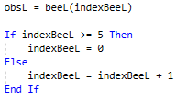

Set of images that will be put on the background is beeL. Because there are only 6 images of beeL, when index indexBeeL is greater than 5, indexBeeL is set to be 0.

## Moving Obstacle to Right Side

This is the code for obstacle to move to right side.

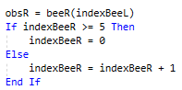

Set of images that will be put on the background is beeR. Because there are only 6 images of beeR, when index indexBeeR is greater than 5, indeBeeR is set to be 0.

## Gets Attacked Facing Left Side

This is the code when Ryu gets attacked facing left side.

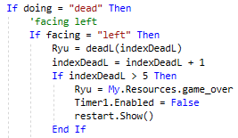

When Ryu gets attacked facing left side, the set of images that will be put on the background is deadL. Because there are only 6 images of deadL, when indexDeadL is greater than 5, indexDeadL is set to be 0.

## Gets Attacked Facing Right Side

This is the code for Ryu get attacked facing right side.

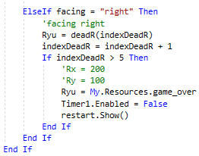

When Ryu gets attacked facing right side, the set of images that will be put on the background is deadR. Because there are only 6 images of deadR, when indexDeadR is greater than 5, indexDeadR is set to be 0.

## Wins

This is the code for Ryu winning the game.

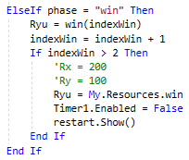

When Ryu wins the game, the set of images that will be put on the background is win. Because there are only 3 images of win, when indexWin is greater than 2, indexWin is set to be 0.

# The Hitboxes are Represented in the Program

Hitboxes store data of RyuAttack and RyuFireball. Both are list of points. RyuAttack will be automatically created when user press the punch key (Tab button). RyuAttack will be generated automatically when attack is True. Then hitbox will be generated on a point where X and Y of Ryu’s sprite is from with transform the shape of the box as the developers want with using CreateBox().

CreateBox() has 4 parameters such as X As Integer, Y As Integer, NX As Integer and NY As Integer that functionated to create hitbox to all of sprite using 2 points,X and Y and NX and NY. NX and NY is gotten from sum of the first point and the width of each sprite.

# The Collision Detection Works in the Program

Collision detection used polygon clipping function from Programming Assignment: Weiler Clipping which has been simplified to be more efficient. The program will check on each variable that has Box. Some of the variable that has Box are RyuBox, RyuFireBall, RyuAttack which are lists of points. Other lists of points are EnemiesBoxFromRight and EnemiesBoxFromLeft. These are different because they use double list to save more than one enemy at a time.

Function to detect collision in this program is IsBoxClip(). It has two parameters which are Enemy As List (Of Point) and Box As List (Of Point). This function functionate to check polygon and will return true if both of polygon is clipped. For the double list such as EnemiesBoxFromRight and EnemiesBoxFromLeft used the same function with looping each of contents of the list.

# Evaluation

This application can be tested by many cases such as make the sprite walk, jump, crouch, etc. The evaluation is shown below.

## Initializing the game

This is the initial appearance to game.

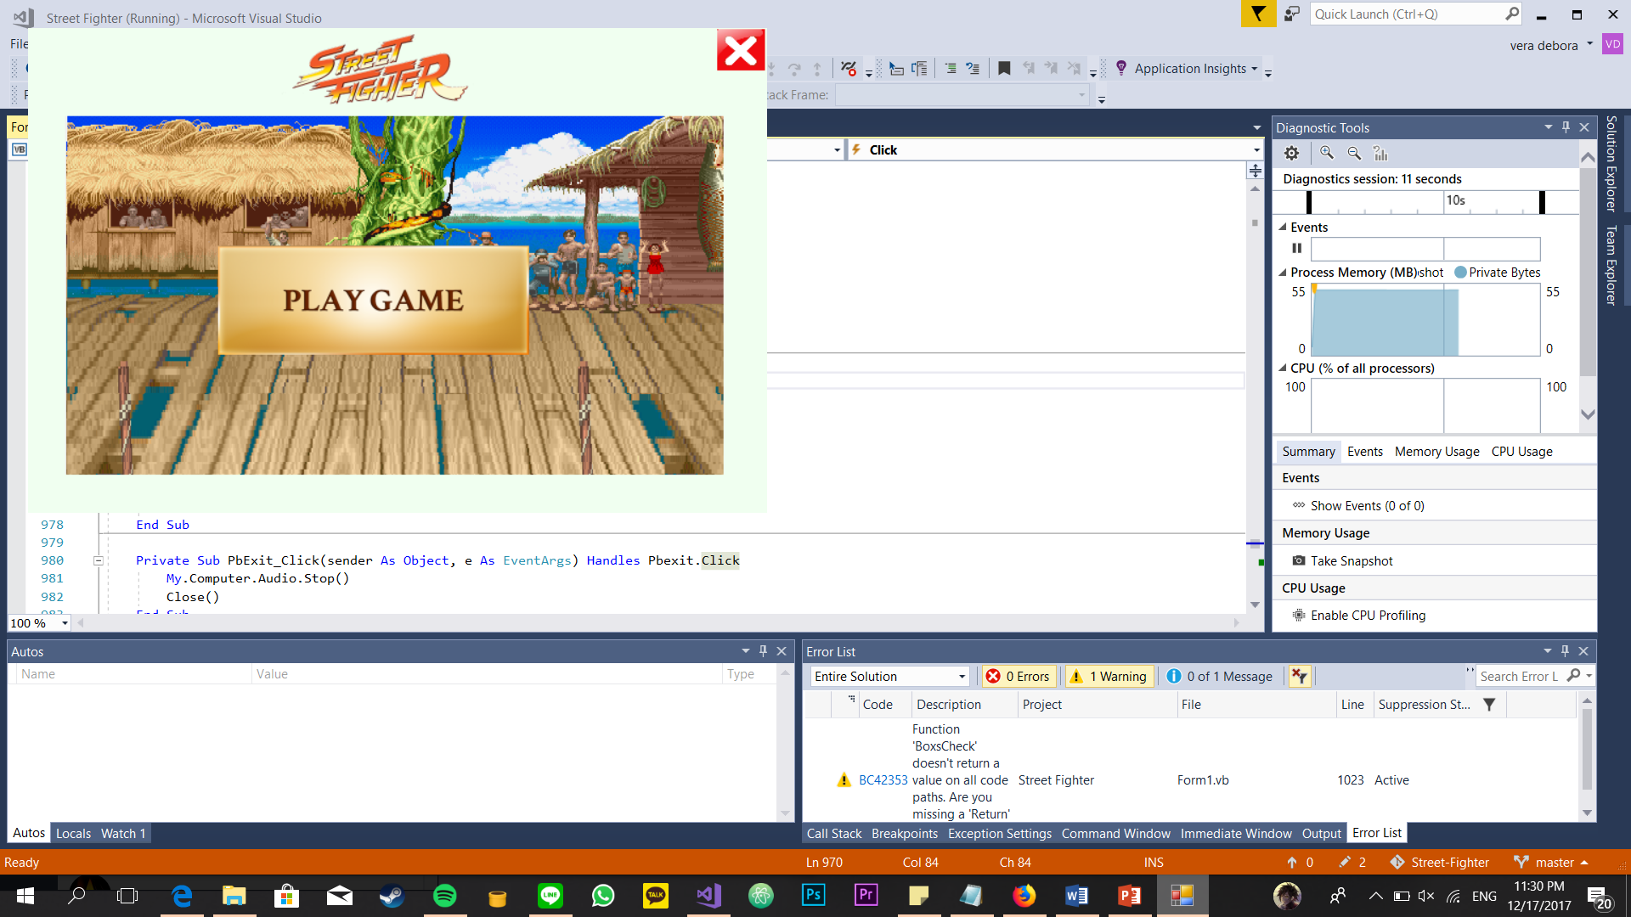

When the user click the “PLAY GAME” button, the fighter will show up and perform the intro animation.

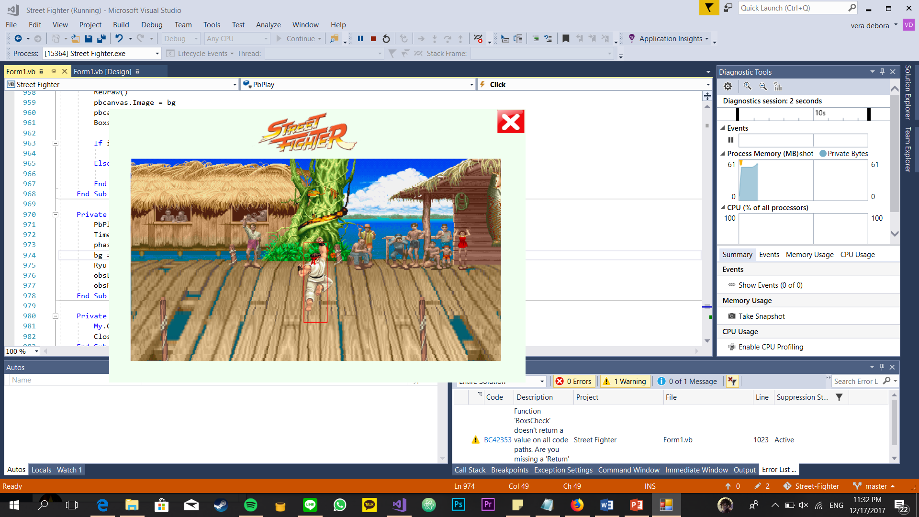

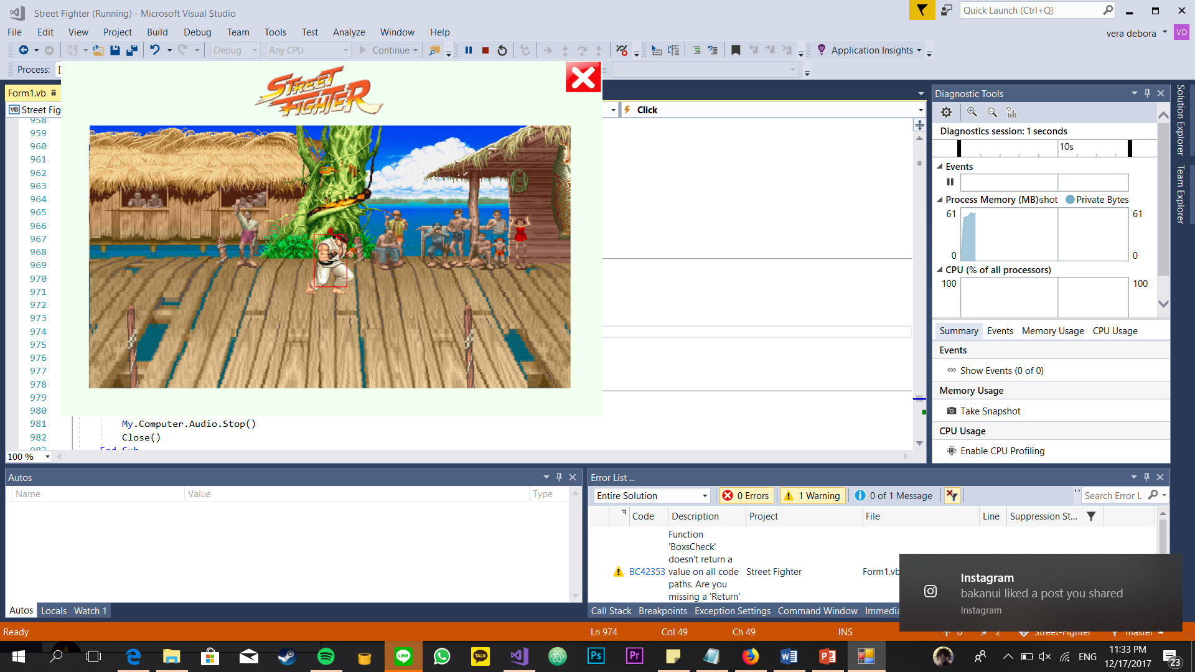

The first obstacle or bee will be shown up after fighter has done its intro animation.

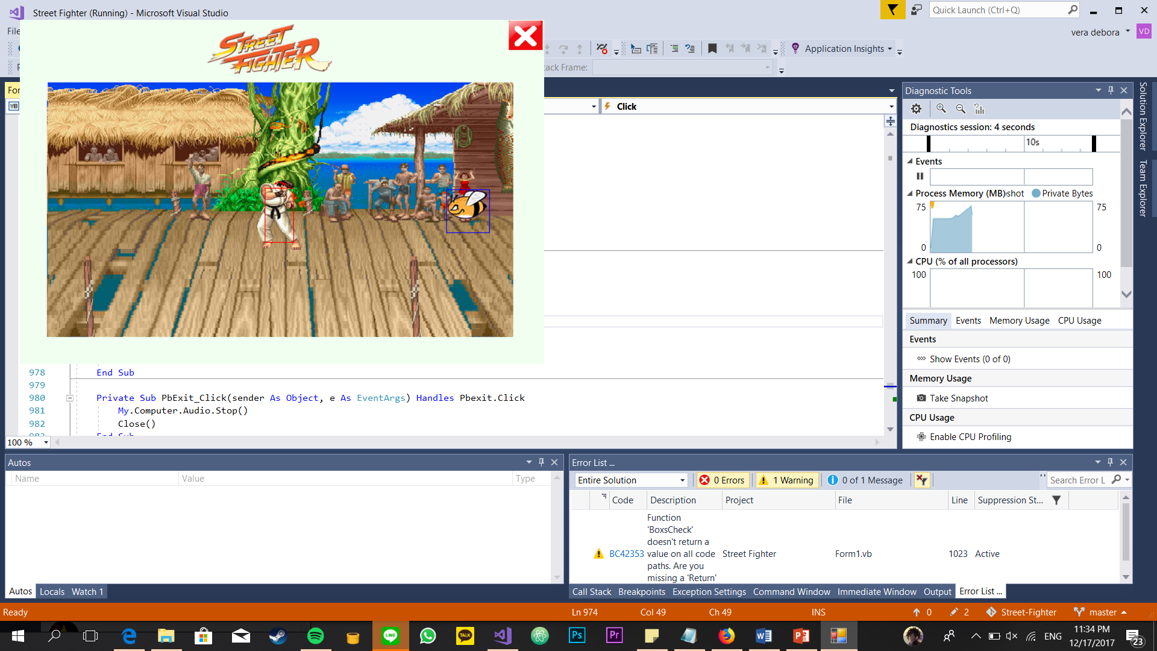

## The fighter walking

The fighter walks to the right. It will face to the right.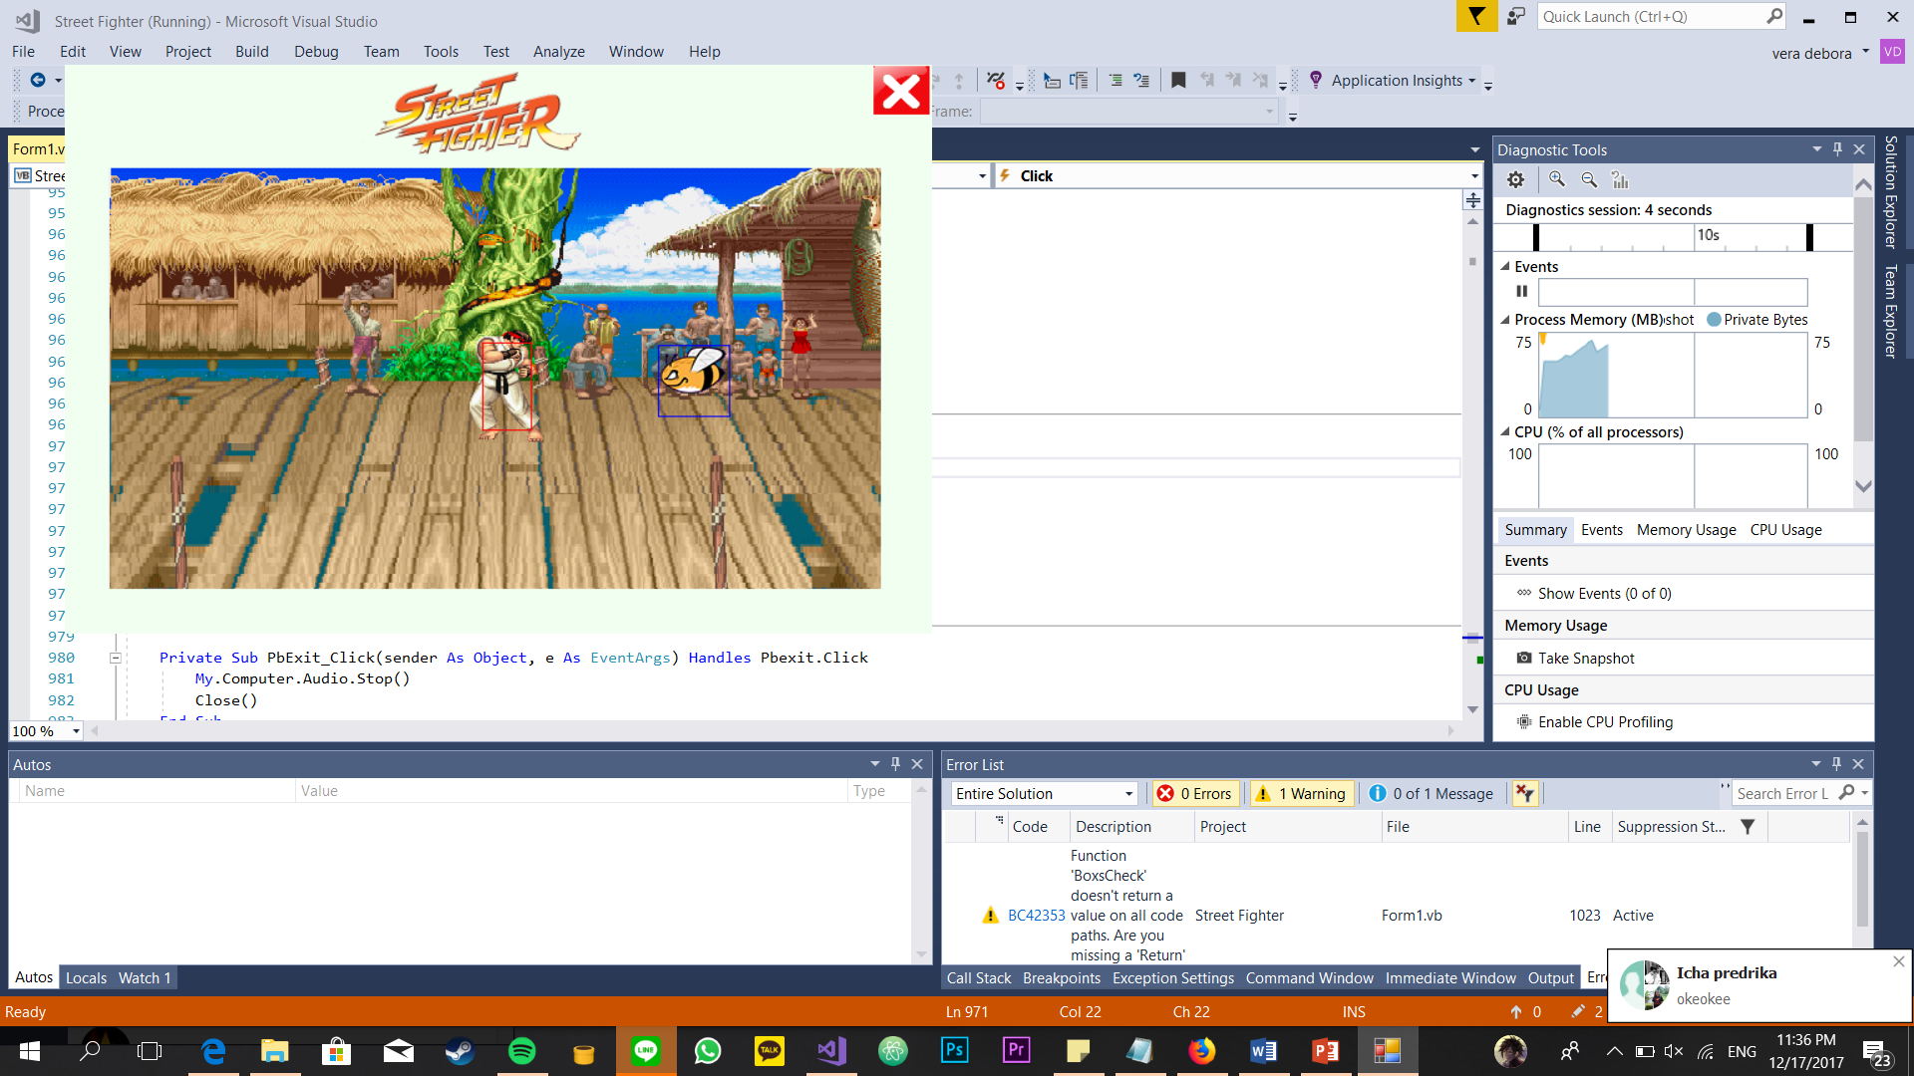

The fighter walks to the left. It will face to the left.

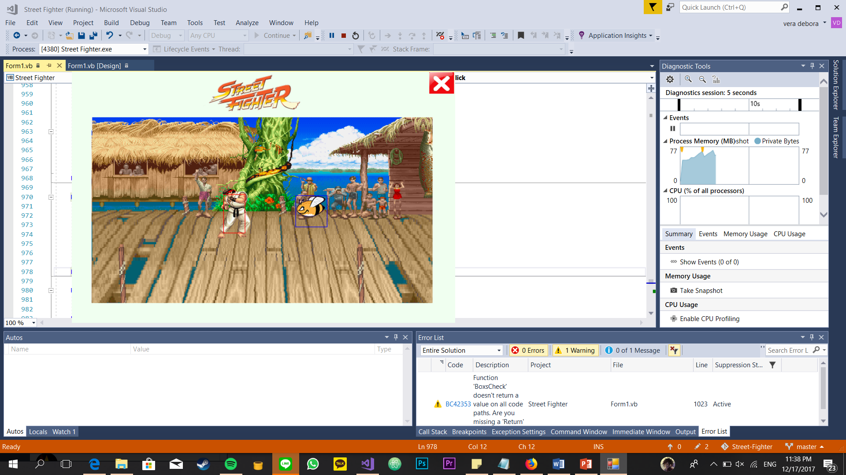

## The fighter jumping (neutral jump and forward jump)

The fighter performs a neutral jump. It will jump up after that it will stand again on the ground.

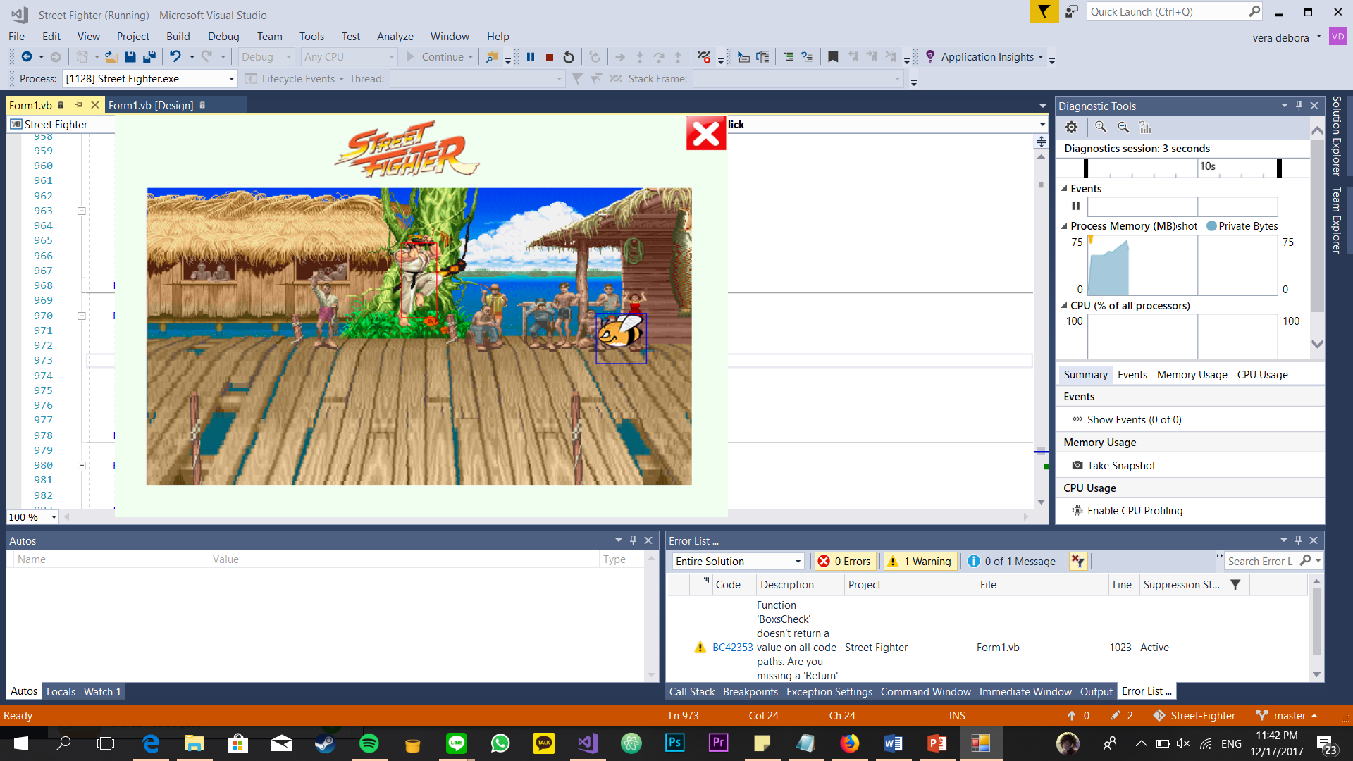

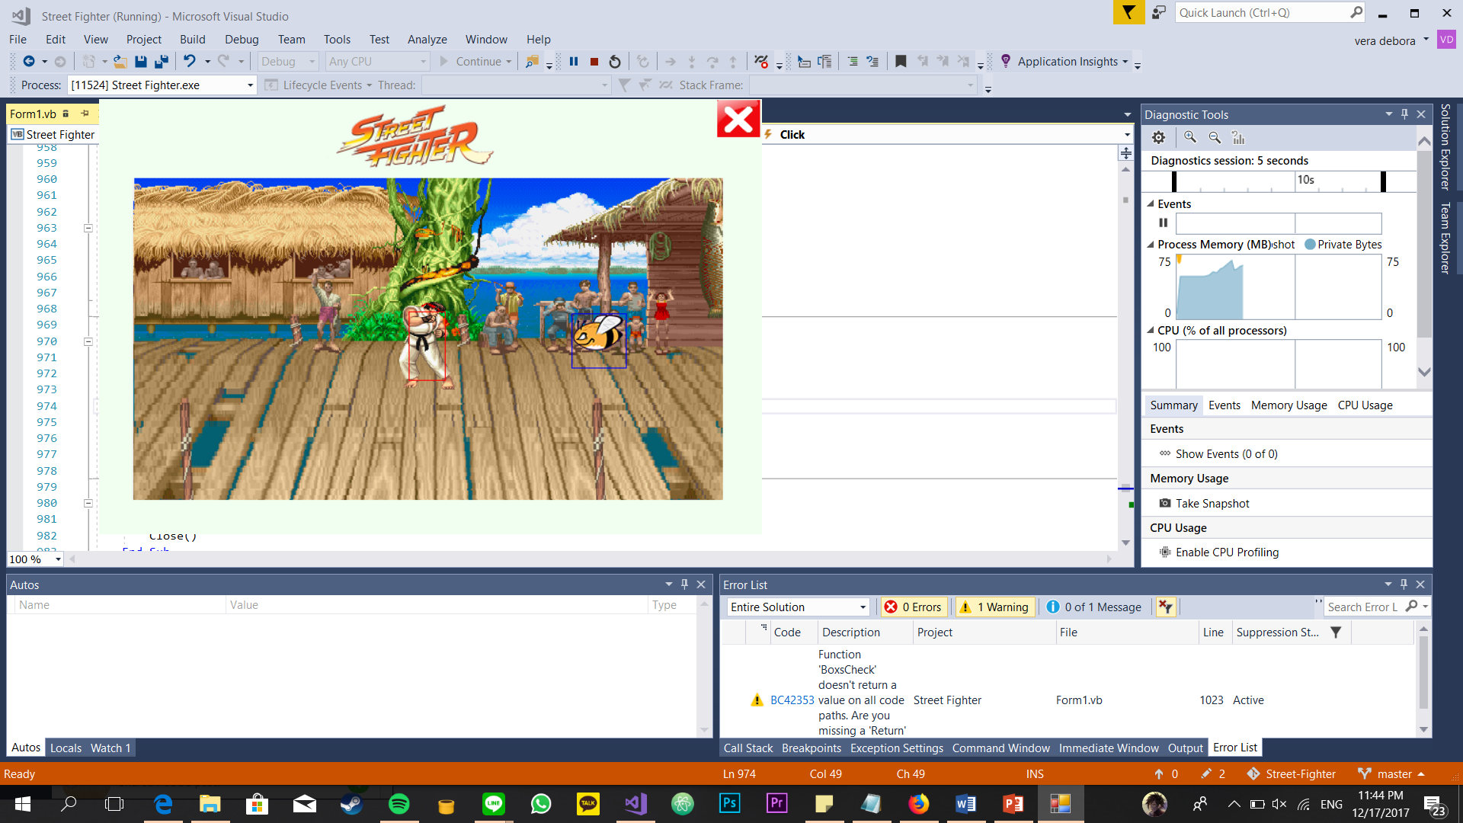

The fighter performs a jump forward to the right.

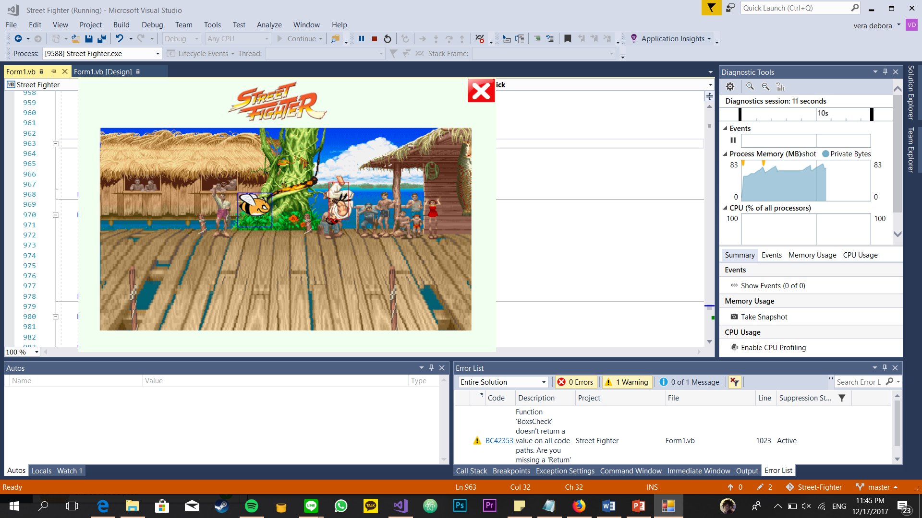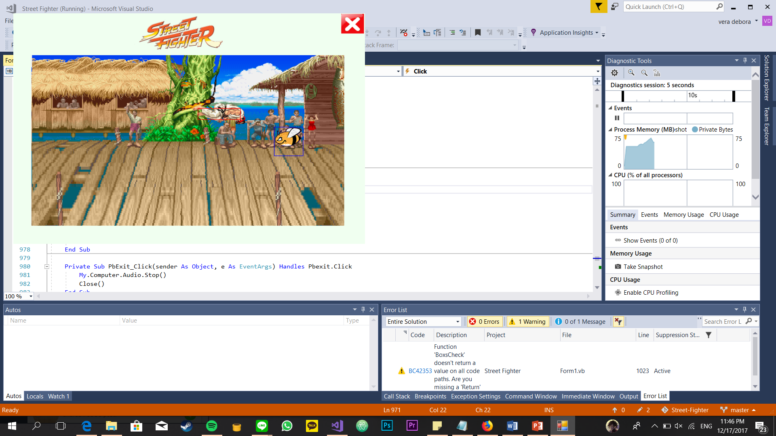

The fighter performs a jump forward to the left.

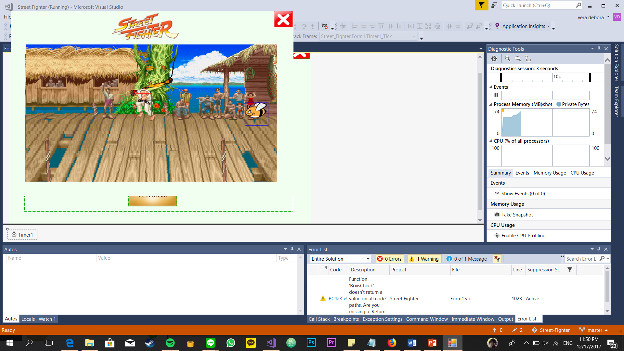

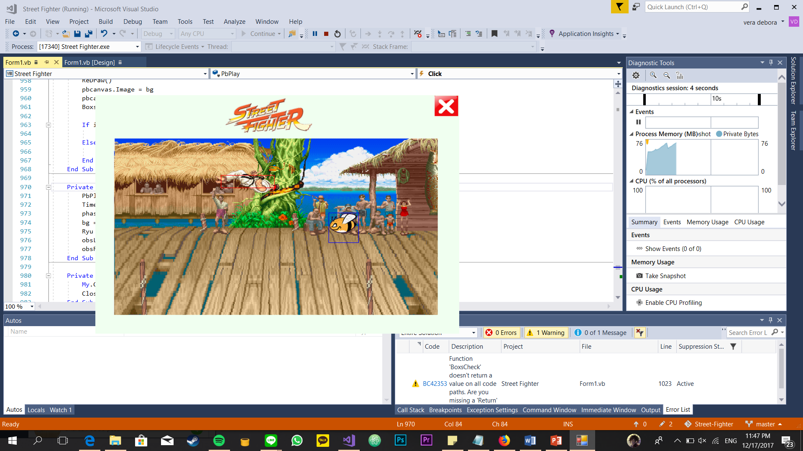

## The fighter crouching

The fighter performs crouch. It faces to the right if the player presses Right Arrow or D on keyboard or if the fighter performs crouch after it perform walk right.

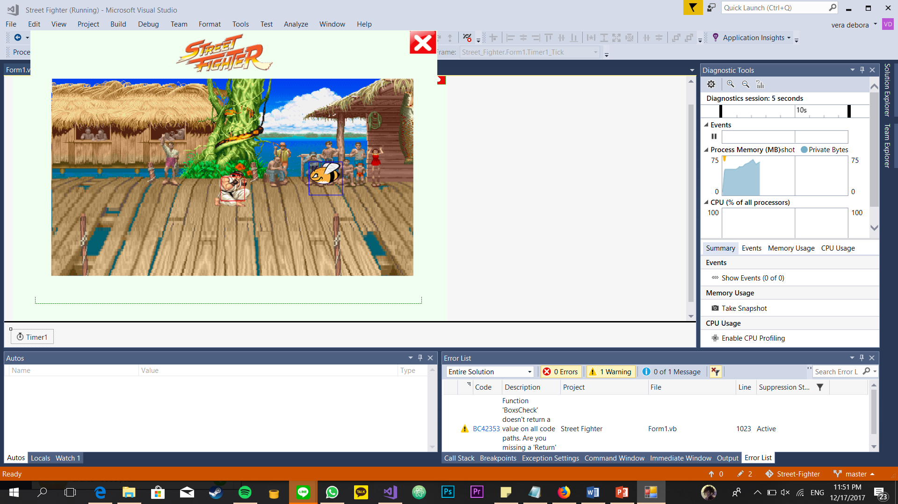

The fighter performs crouch. It faces to the left if the fighter performs crouch after it perform walk left.

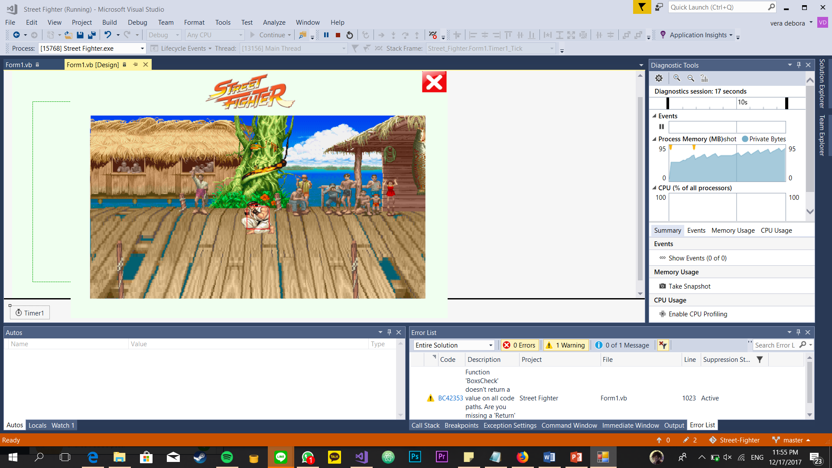

## The fighter performing an attack (while standing, jumping, and crouching)

The fighter performs an attack while standing. The yellow box (attack box) will show up.

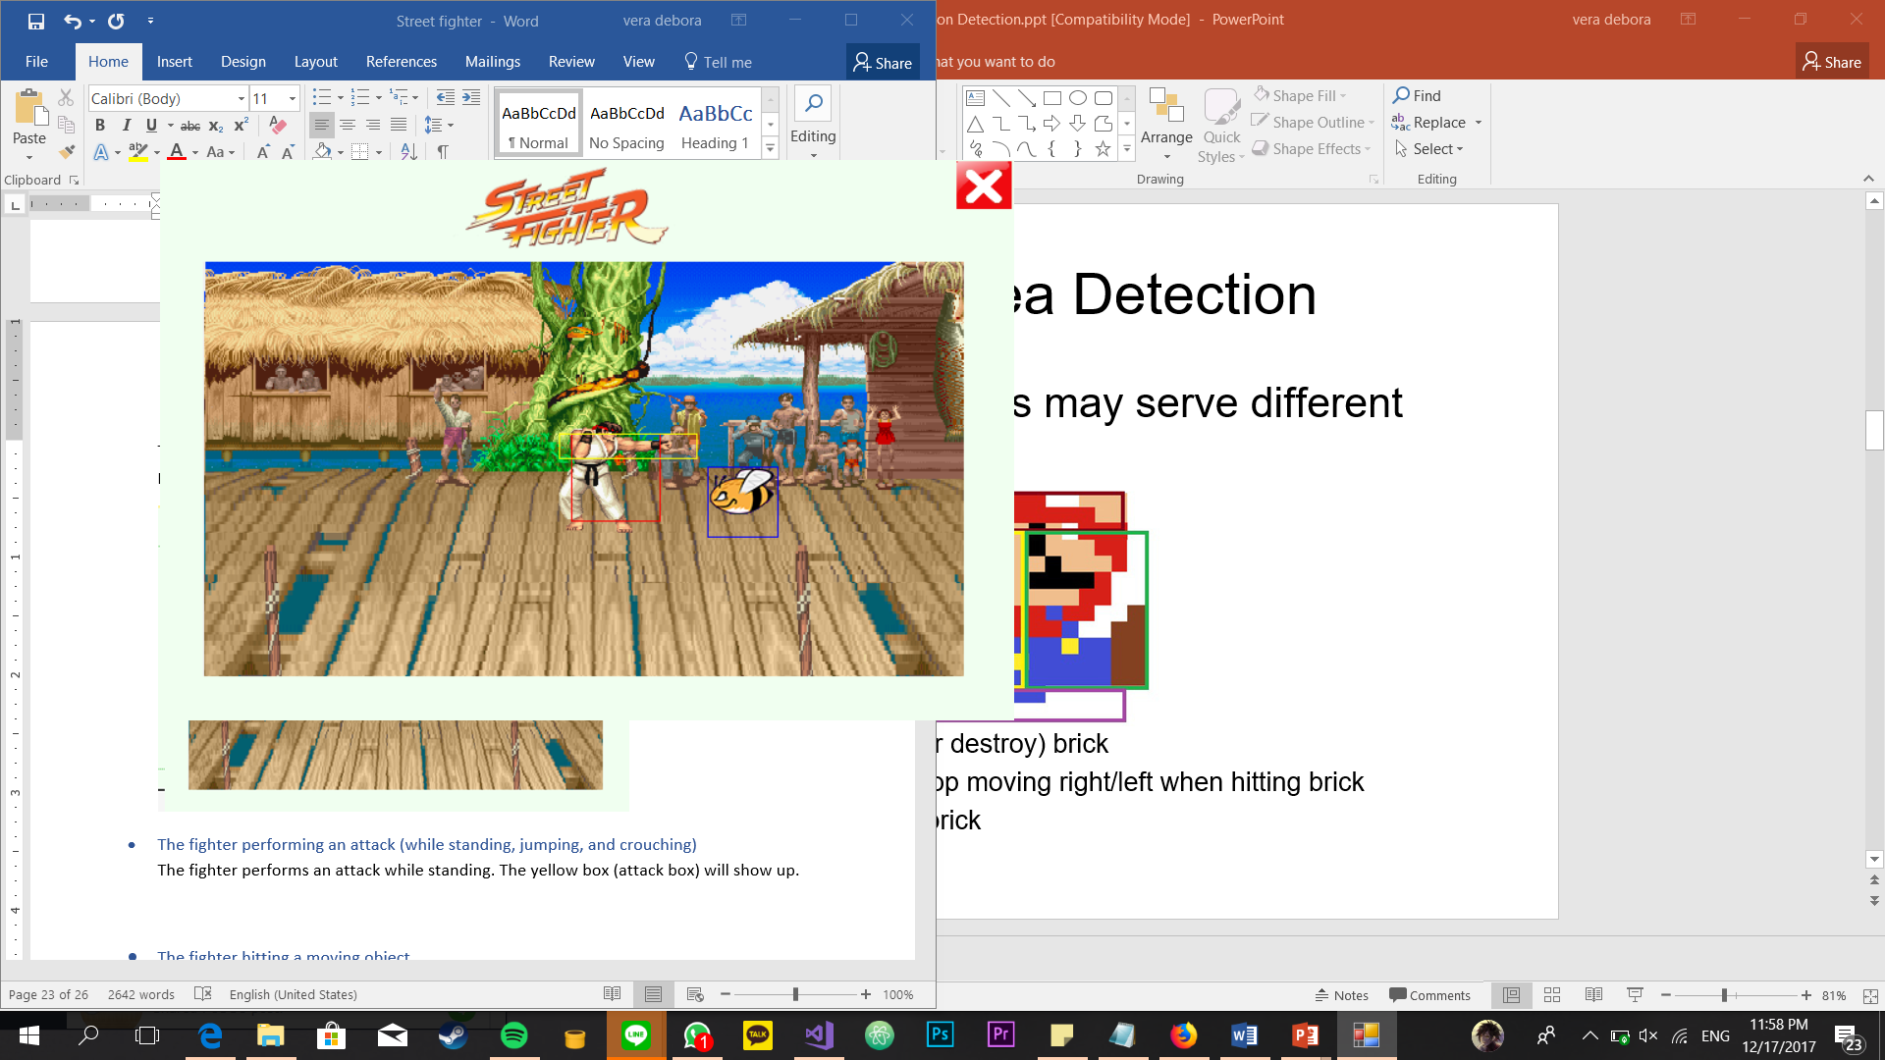

The fighter performs an attack while jumping. The yellow box (attack box) will show up.

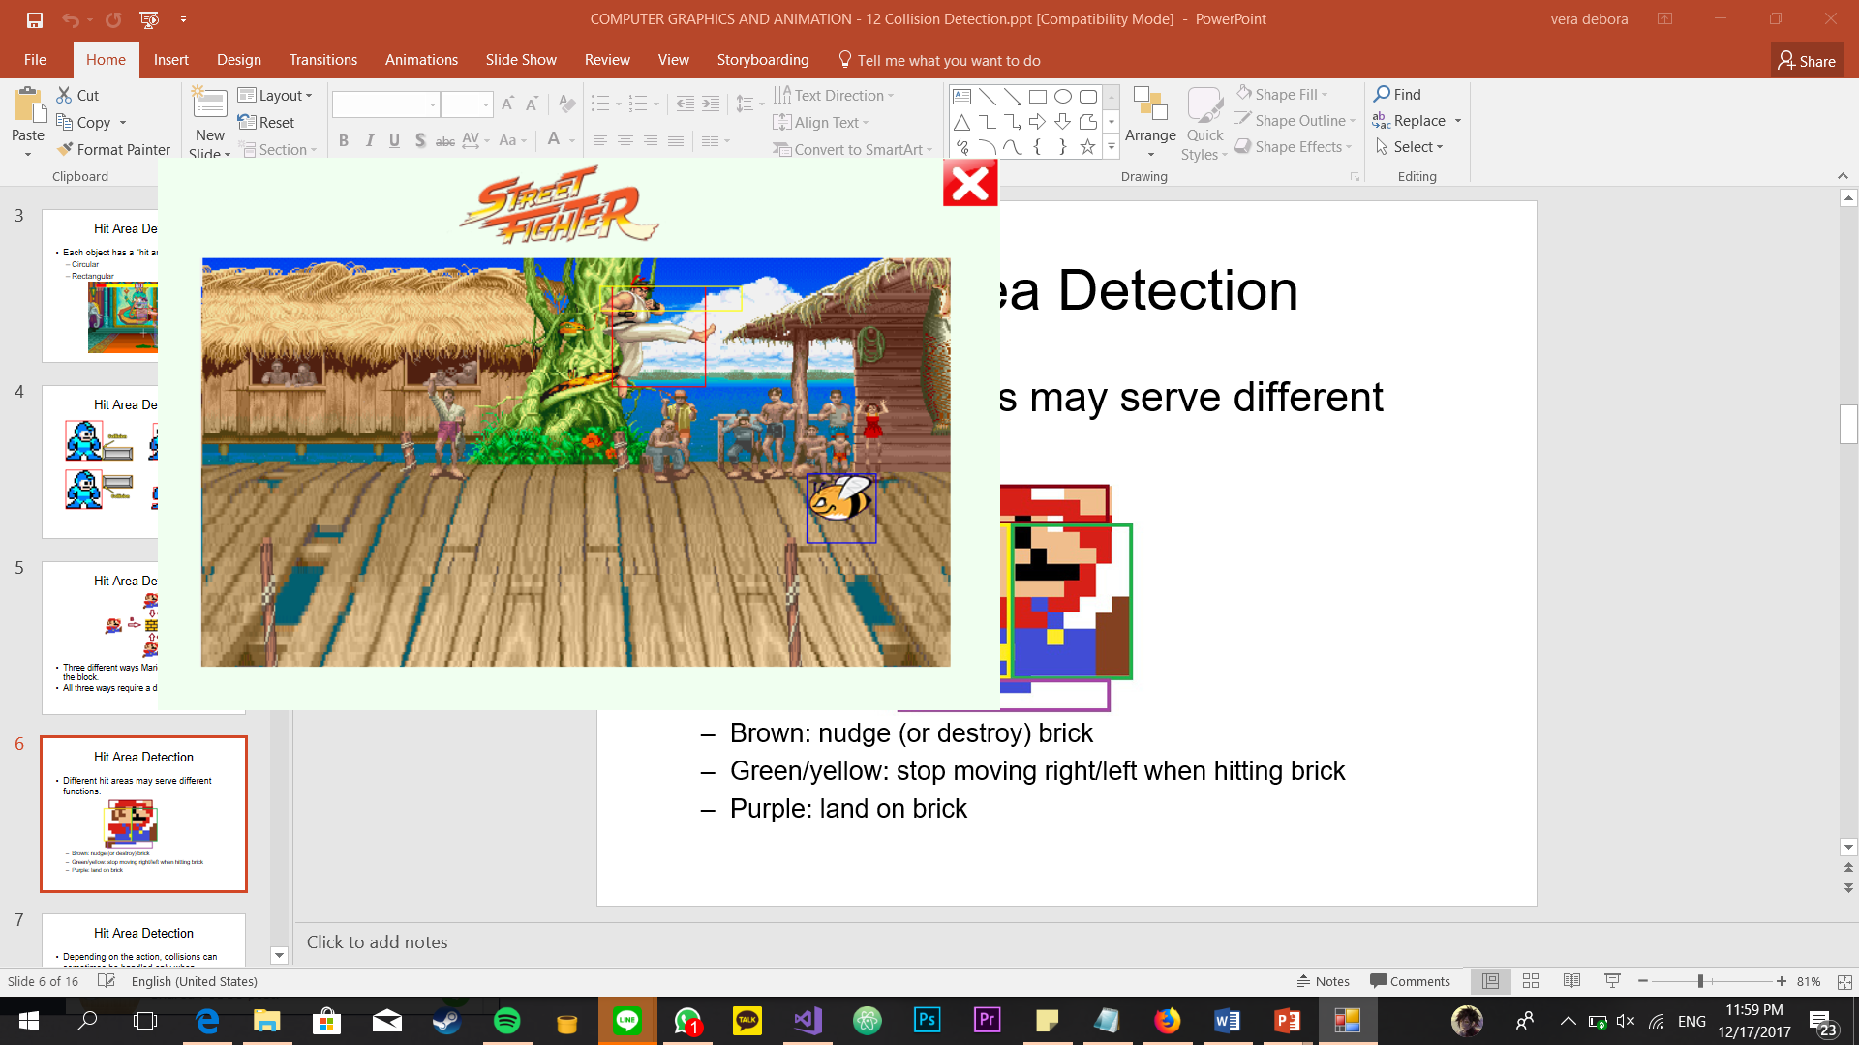

The fighter performs an attack while crouching. The yellow box (attack box) will show up.

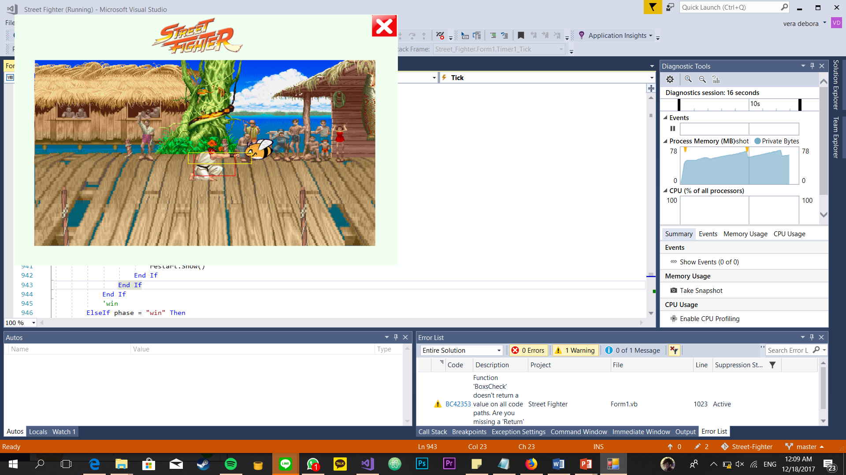

## The fighter hitting a moving object

When the fighter hits a moving object (obstacle), the moving object will be disappear.

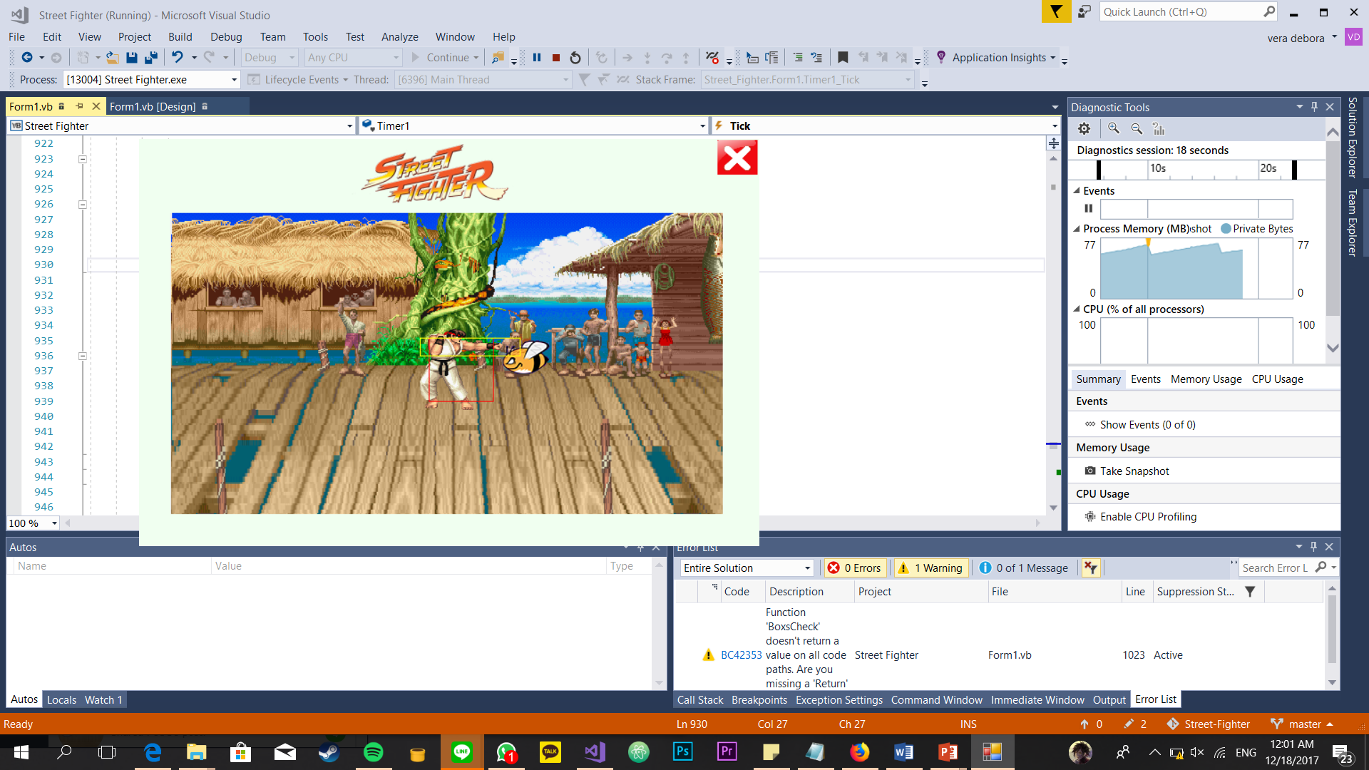

After the first bee had been attacked, the second bee will be show up randomly.

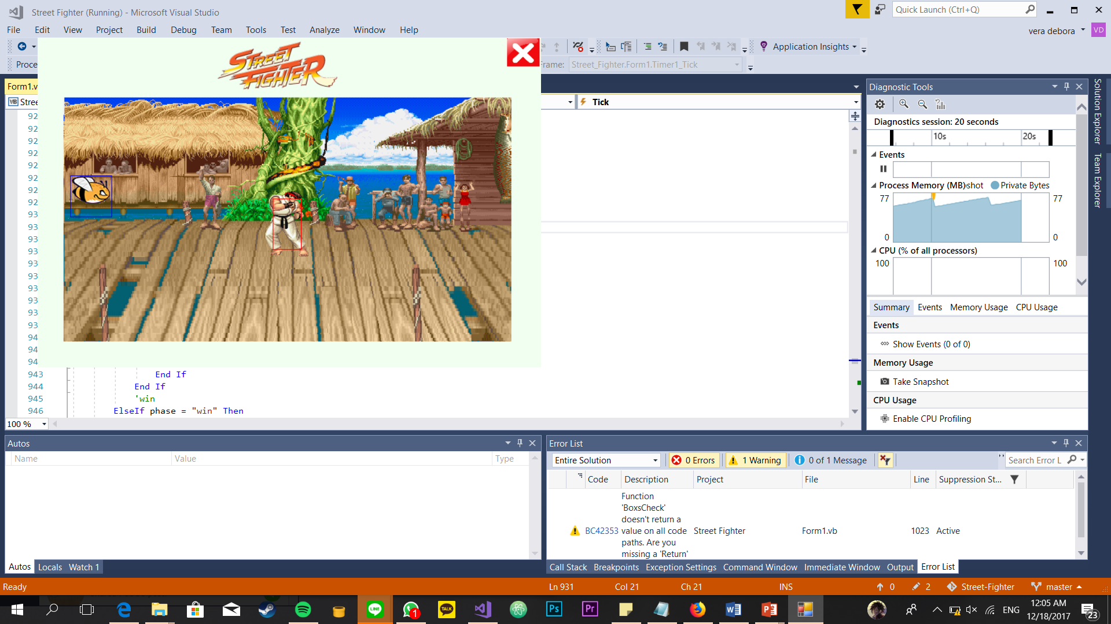

## The fighter getting hit by a moving object

When the fighter getting hit by a moving object (obstacle), the obstacle will be disappear, and the fighter will perform the death animation.

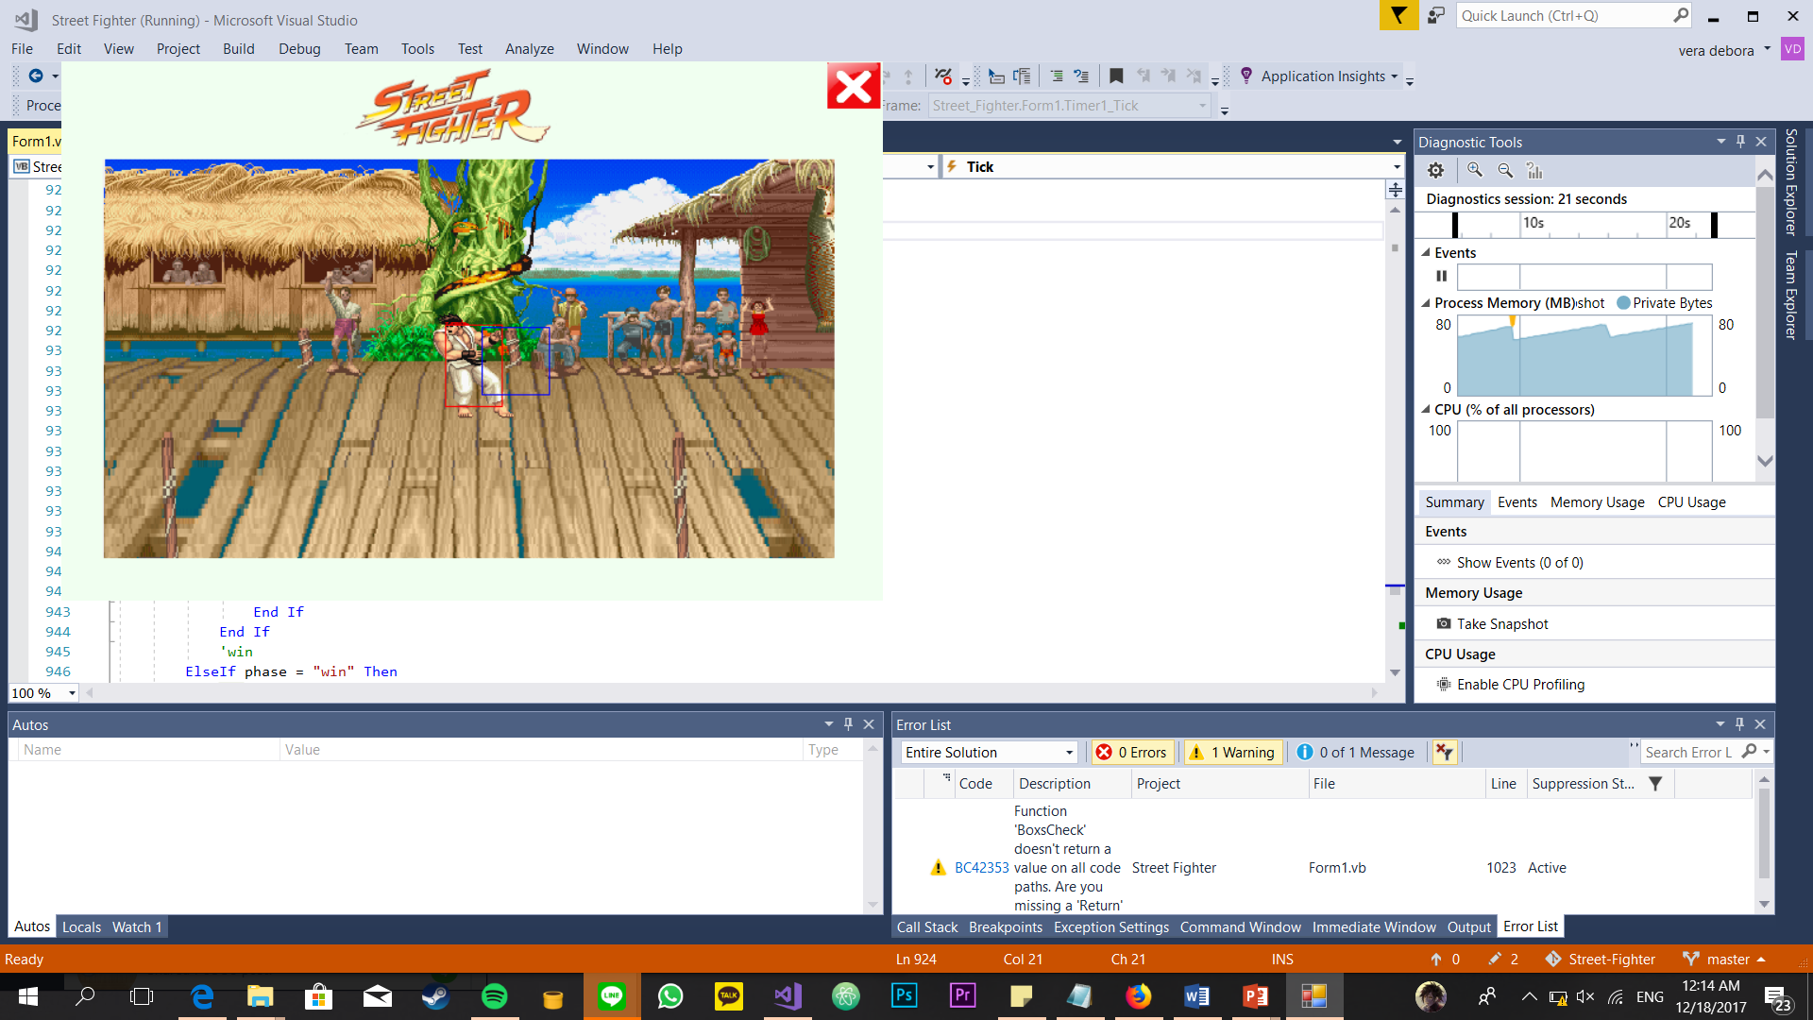

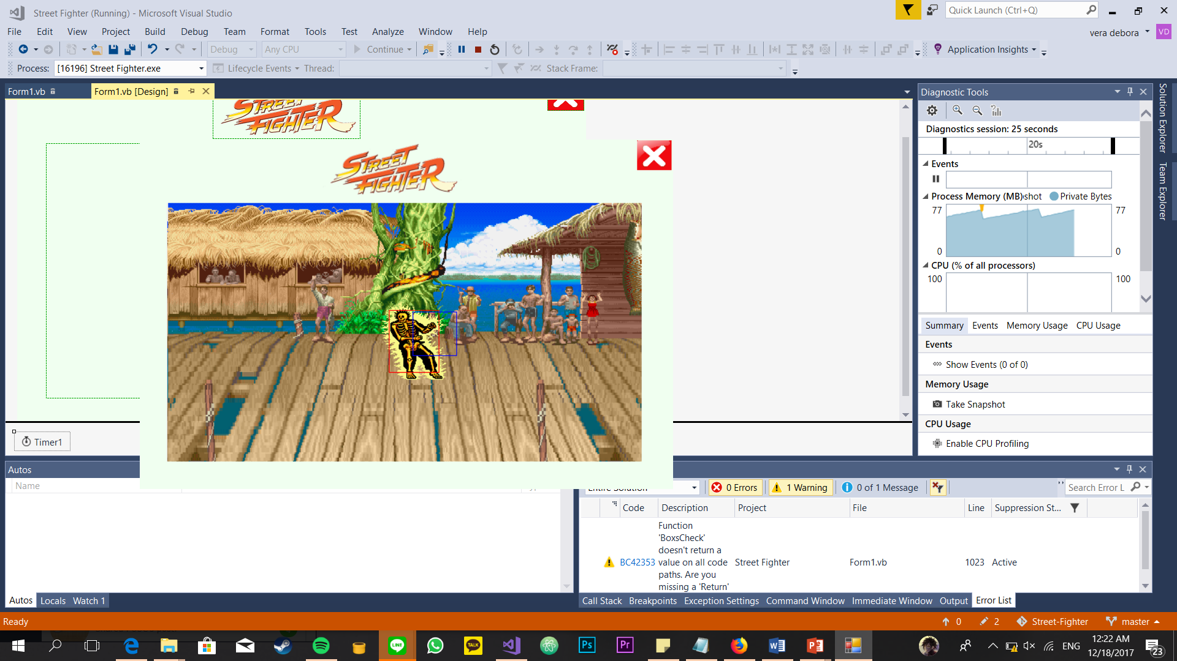

## Test cases for bonus that implemented in this program

1. Display the death/losing animation of the fighter.





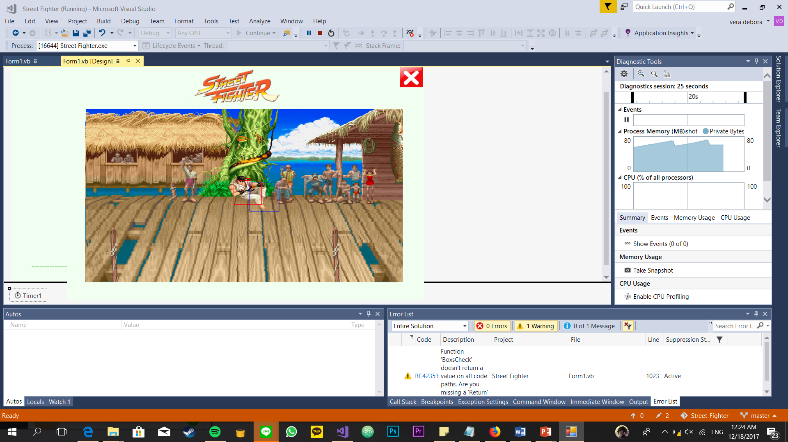

1. Perform a fireball attack. The fighter launches as fireball (preferably hadouken) that moves horizontally.

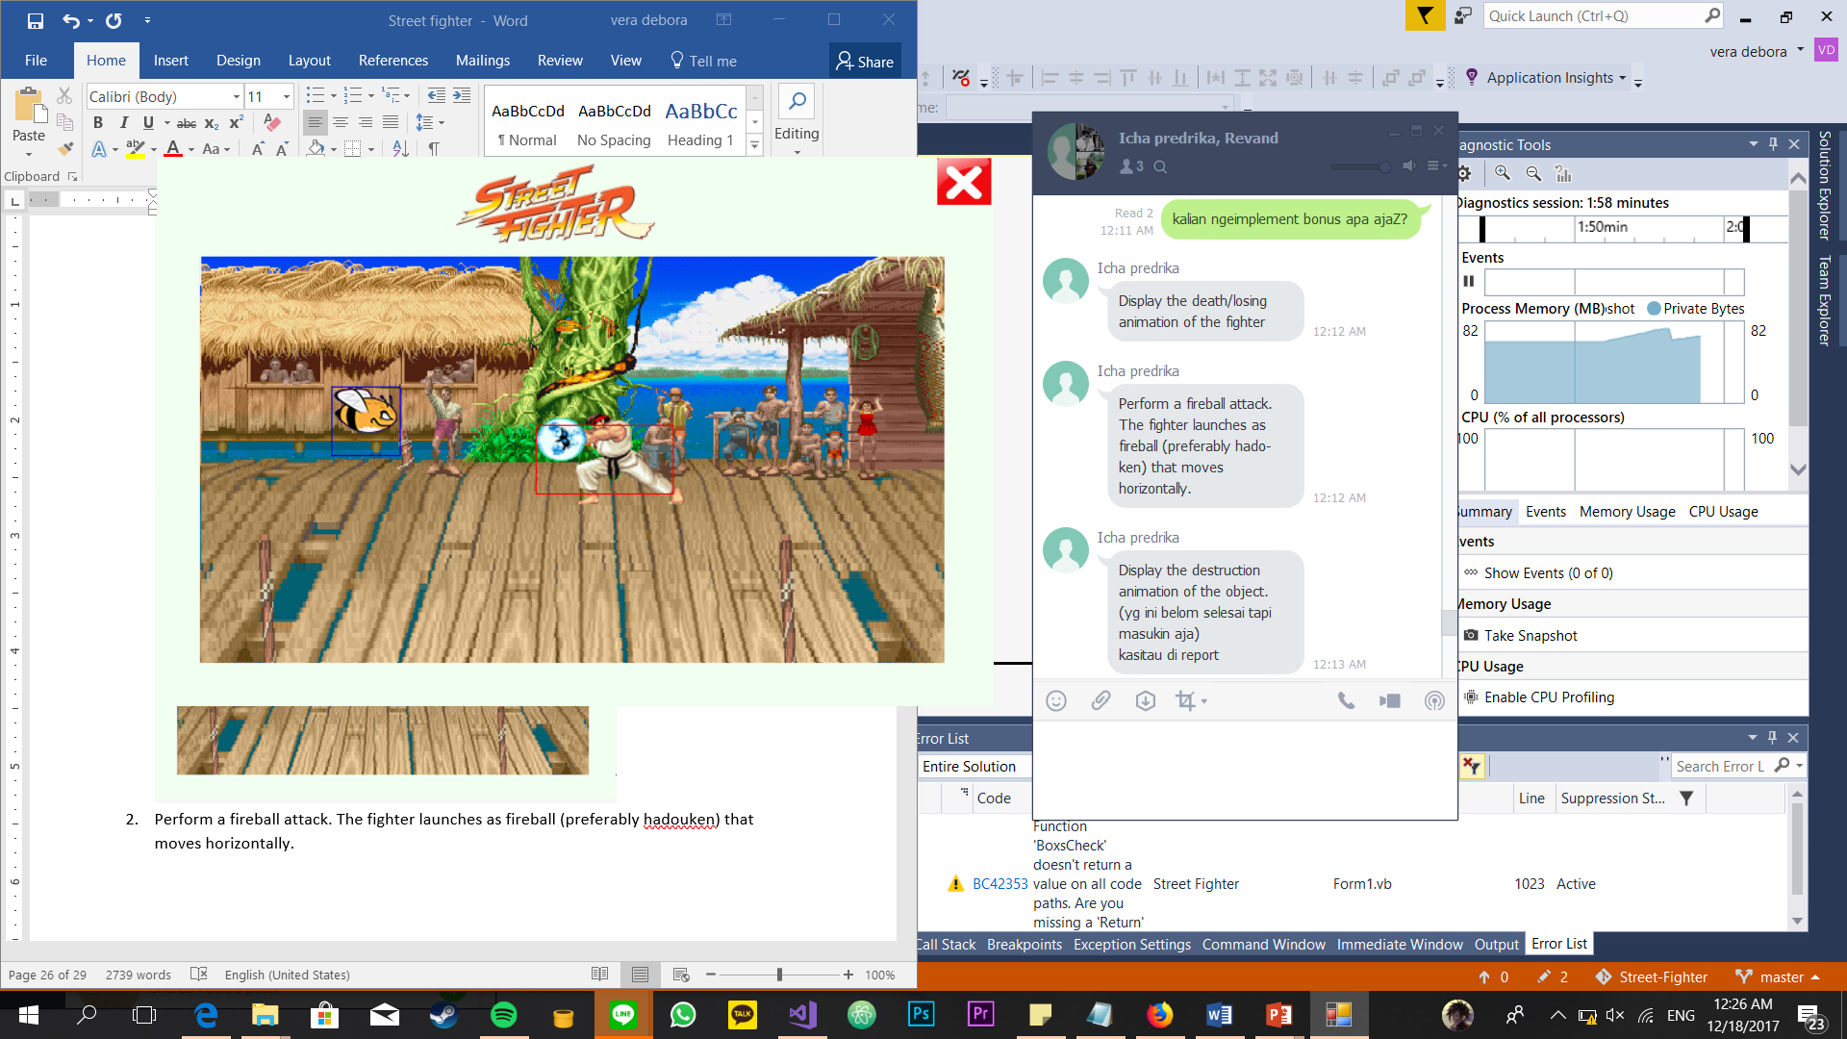

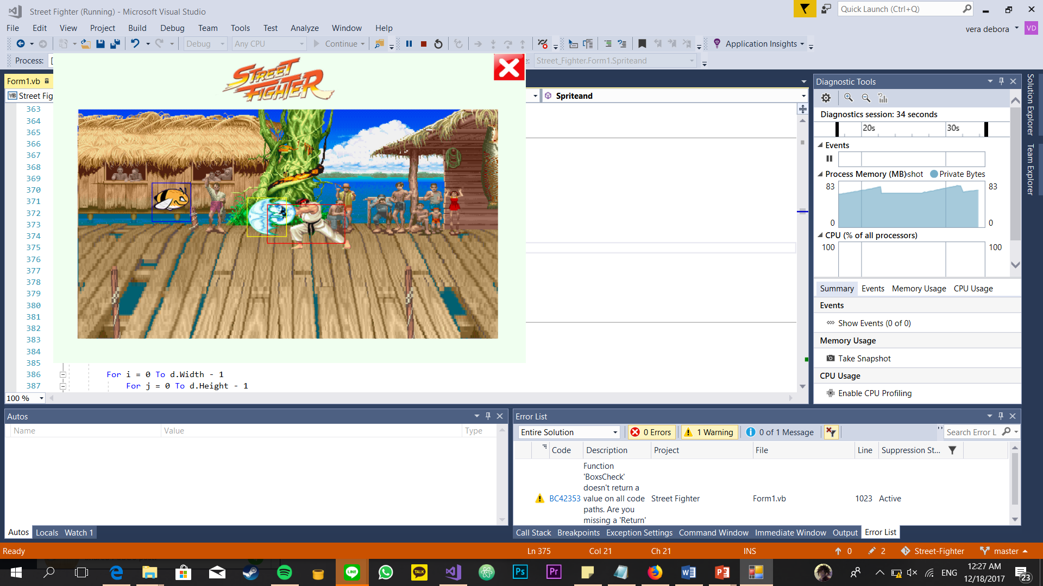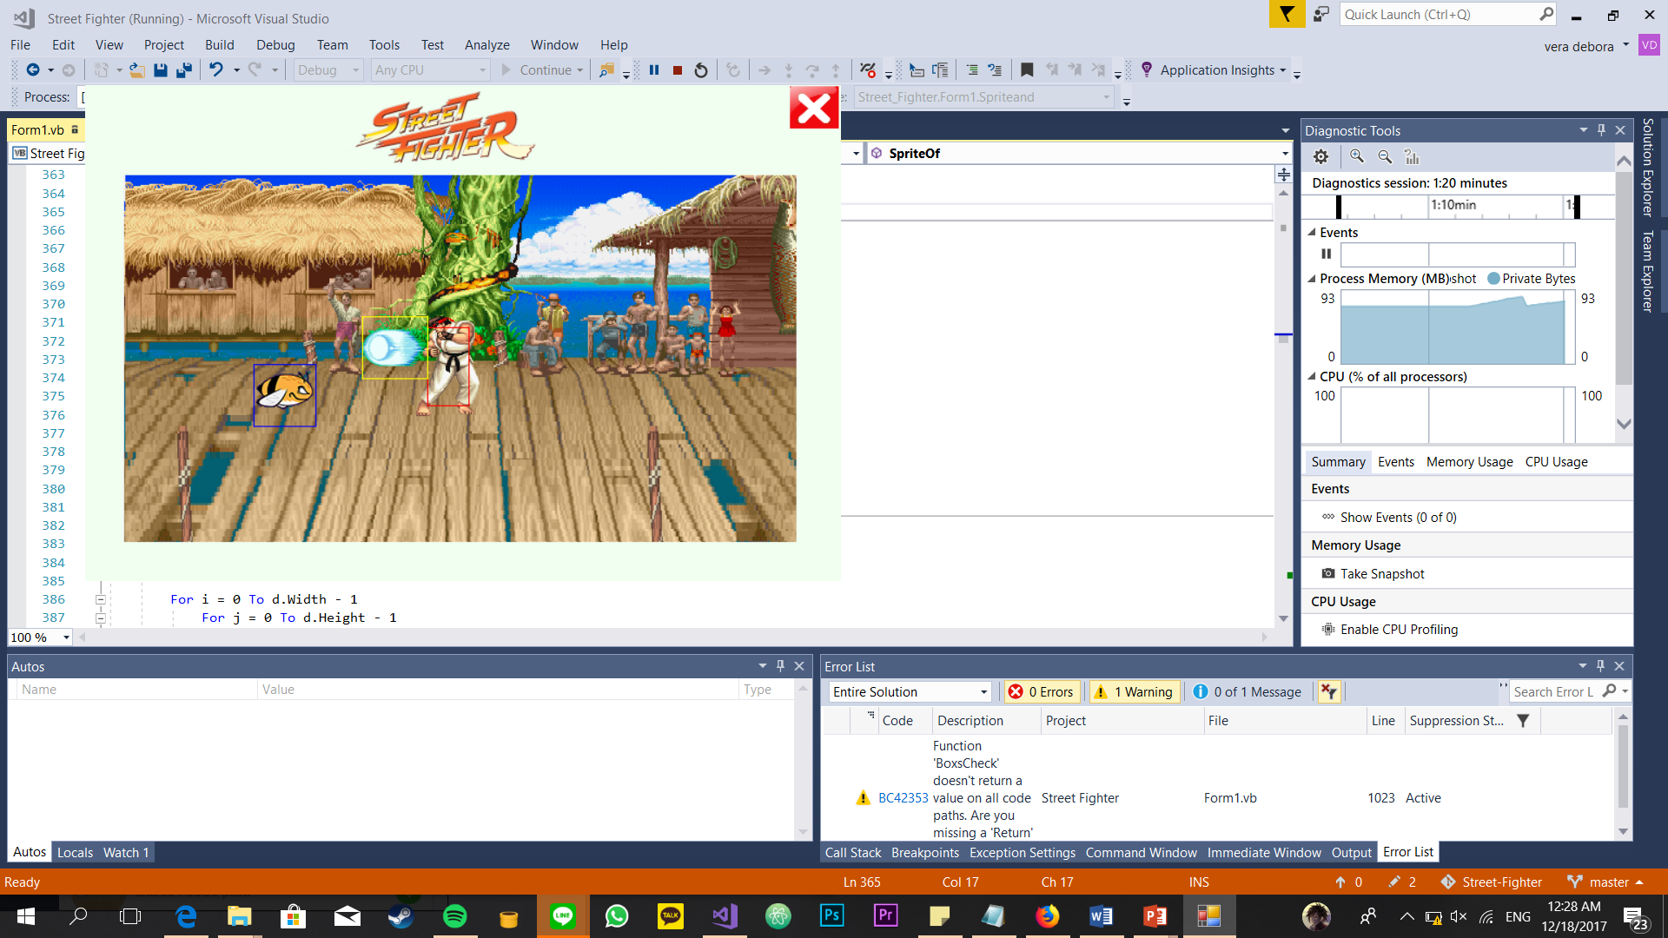

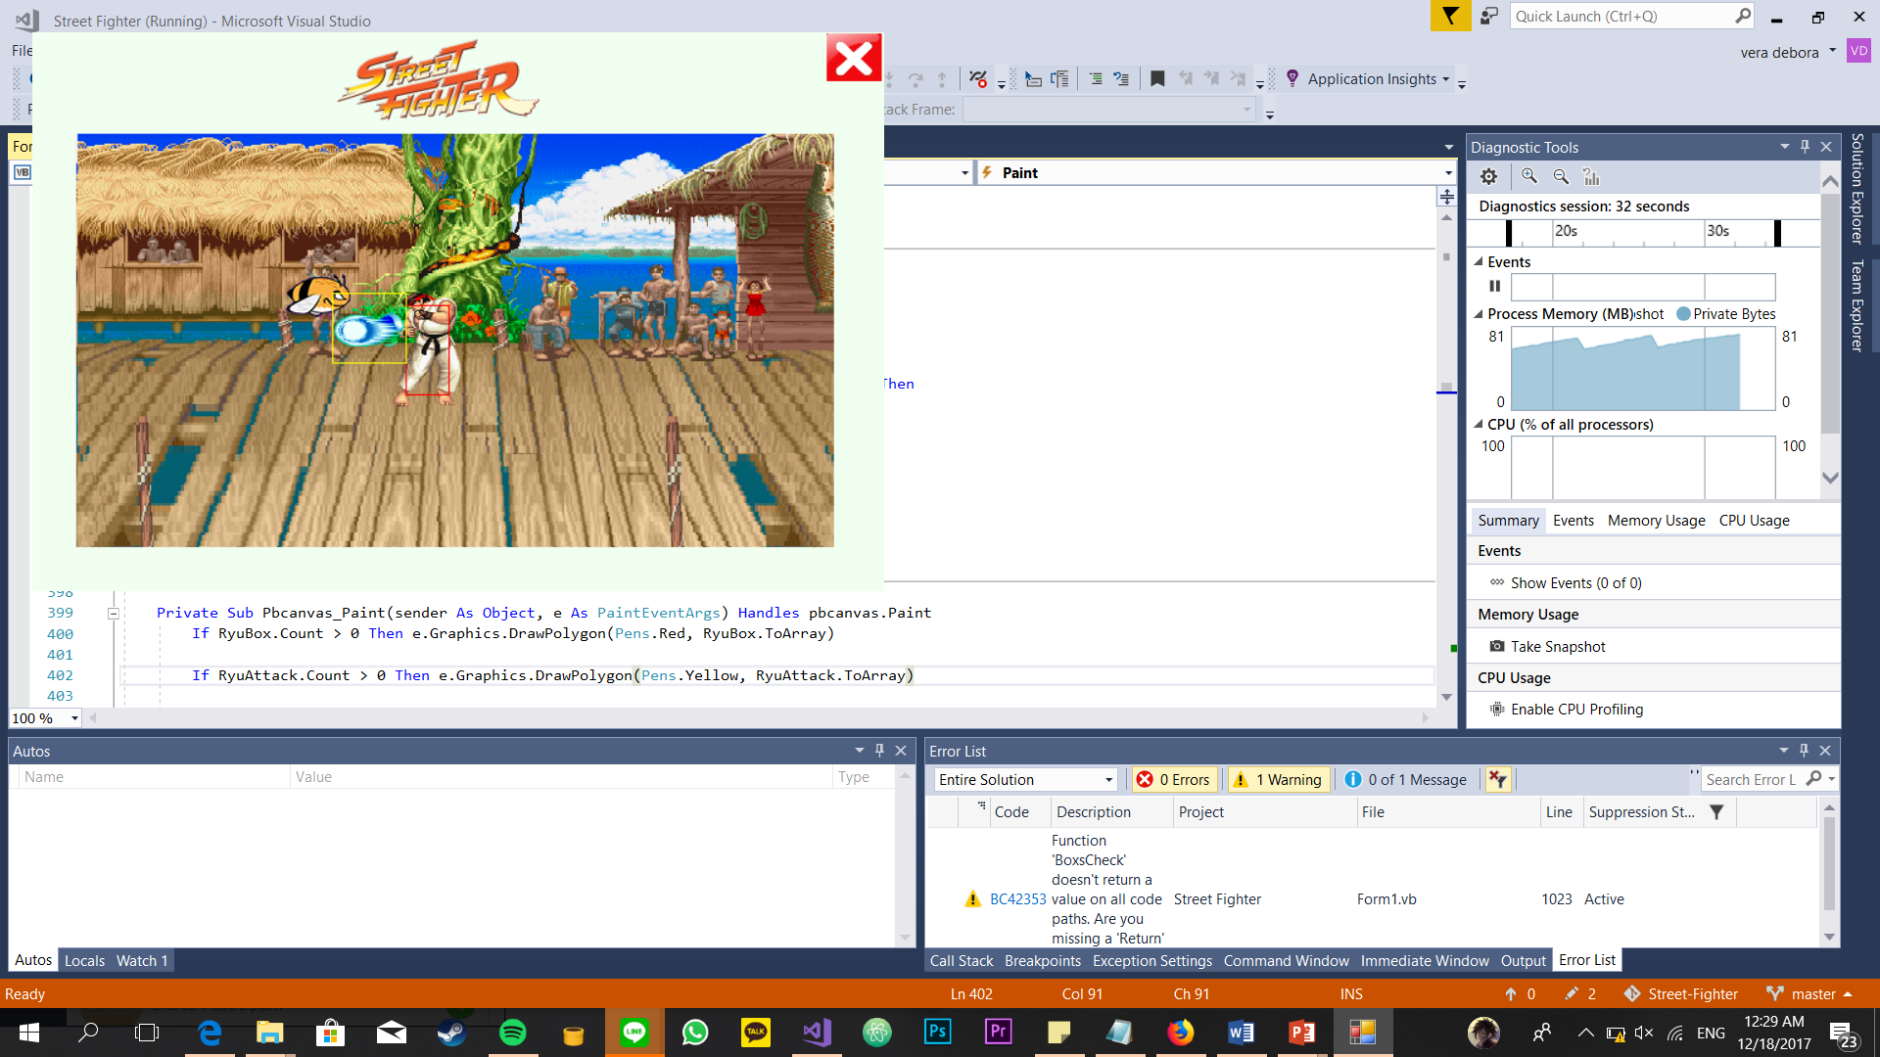

1. Display the destruction animation of the object. But, this bonus hasn’t implemented completely. There are some bugs in this bonus.

# Work Log

The work log is extracted directly from Visual Studio’s Git Log History, which is also available publicly at <https://github.com/ichapredrika/Street-Fighter/commits/master>

|  |  |  |  |  |
| --- | --- | --- | --- | --- |
| No | Author | Date | Time | Commit Message |
| 1 | Predrika | 3/12/2017 | 13:57:09 | - edit sprites for intro and stand  - masking sprites  - 'and' and 'or' operate mask and sprite  - timer for sprites  - add intro  - add stand |
| 2 | Predrika | 3/12/2017 | 18:27:25 | - add StandL, Crouch left and right  - user interface |
| 3 | Predrika | 4/12/2017 | 20:56:18 | -add backsound  -fix error |
| 4 | Predrika | 4/12/2017 | 00:56:57 | -fix bug  -change direction  - add crouch |
| 5 | Predrika | 5/12/2017 | 10:17:11 | - make the sprite walk  - add min and max of edge that sprite can't cross |
| 6 | Predrika | 5/12/2017 | 12:27:49 | - Report draft(full)  - IV. The Background and Sprites Used in the Program |
| 7 | Predrika | 6/12/2017 | 16:20:35 | - Fix jump  - jump left(back)  - jump right(Forward)  - add exception (when Ryu wants to jump forward or backward on the edge of picturebox, it'll be only a decent jump)  - add more control "A,S,D,W,Q,E" |
| 8 | Predrika | 6/12/2017 | 16:20:35 | - fix bug (when the sprite jump at the edge of the picture box) |
| 9 | Predrika | 9/12/2017 | 21:58:11 | - edit obstacle left and right  - add obstacle left and right (not functionated yet) |
| 10 | Hilman | 9/12/2017 | 07:06:39 | - collision |
| 11 | Predrika | 9/12/2017 | 22:15:58 | - edit background of obstacle (to be transparent) |
| 12 | Hilman | 9/12/2017 | 07:59:37 | - create ryubox, movebox and allow ryu to move while he jump |
| 13 | Hilman | 9/12/2017 | 09:02:14 | - create enemybox  - create condition function so ryu able to move when he jump and crouch |
| 14 | Hilman | 9/12/2017 | 13:40:15 | - detect hit ryubox with all of enemy’s boxes |
| 15 | Predrika | 10/12/2017 | 18:24:04 | - edit hadouken left and right  - edit and add code jump left and jump right  - edit and add code crouch left and right  - on report, add VI. How the Background and Sprites are Represented in the Program and add Sprite sheet |
| 16 | Predrika | 10/12/2017 | 20:03:21 | - Add hadouken left and right's code |
| 17 | Hilman | 10/12/2017 | 22:34:47 | - create function to move sprite with box in the same time |
| 18 | Hilman | 10/12/2017 | 23:39:50 | - create random enemy position (just box) |
| 19 | Hilman | 11/12/2017 | 00:19:48 | - move random enemies |
| 20 | Predrika | 12/12/2017 | 10:43:22 | - fix jump forward |
| 21 | Predrika | 11/12/2017 | 19:58:36 | - edit dead left and right image  - add dead left and right code |
| 22 | Mr. Eddo | 11/12/2017 | 21:05:16 | - fix bugs |
| 23 | Predrika | 11/12/2017 | 23:09:39 | - edit jump forward  - convert 3 timers to be 1 |
| 24 | Predrika | 16/12/2017 | 21:44:37 | - edit all sprites |
| 25 | Predrika | 16/12/2017 | 22:46:54 | - change jump left and right |
| 26 | Predrika | 16/12/2017 | 23:00:20 | -edit hadouken |
| 27 | Hilman | 16/12/2017 | 08:25:21 | -fix bug |
| 28 | Predrika | 16/12/2017 | 23:38:29 | - Punch left and right |
| 29 | Predrika | 16/12/2017 | 00:20:00 | - punch crouch left and right |
| 30 | Predrika | 16/12/2017 | 01:23:29 | - attack when jump left and right |
| 31 | Predrika | 16/12/2017 | 01:40:43 | - move the obstacle from left to right |
| 31 | Hillman | 16/12/2017 | 10:49:17 | - box = sprite |
| 32 | Hilman | 16/12/2017 | 11:01:05 | - move obs left to right (ex) |
| 33 | Hilman | 16/12/2017 | 12:24:27 | - hit box |
| 34 | Predrika | 17/12/2017 | 03:01:03 | -create and add the death of bee left and right |
| 35 | Predrika | 17/12/2017 | 03:25:22 | -game over and count  -add phase win |
| 36 | Predrika | 17/12/2017 | 15:31:33 | -hadouken left and right(bugged)  -edit jump |
| 37 | Predrika | 17/12/2017 | 15:37:49 | -fix bug |
| 38 | Hilman | 17/12/2017 | 00:59:03 | - remove enemy when the enemy attacked |
| 39 | Predrika | 17/12/2017 | 20:31:25 | IV. The Background and Sprites Used in the Program |
| 40 | Predrika | 17/12/2017 | 19:09:59 | - game over screen |
| 41 | Predrika | 17/12/2017 | 19:35:14 | - fix bug  - win |
| 42 | Hilman | 17/12/2017 | 04:52:54 | - add difficulty lv and show the enemies in random side |
| 43 | Hilman | 17/12/2017 | 05:17:22 | - add hit box to fireball |
| 44 | Hilman | 17/12/2017 | 06:26:08 | -fix overlap pixel |
| 45 | Hilman | 17/12/2017 | 23:08:24 | -finishing |
| 46 | Predrika | 17/12/2017 | 23:30:02 | V. The Actions for the Fighter Defined in the Program  VII. The Actions and Animations of the Sprites Represented in the Program |
| 47 | Nikita | 17/12/2017 | 23:42:31 | I. Introduction  II. Basic Theory |
| 48 | Hilman | 17/12/2017 | 23.51:00 | VII. The Hitboxes are Represented in the Program |
| 49 | Predrika | 17/12/2017 | 23.54:23 | III. Features |
| 50 | Hilman | 17/12/2017 | 23.54:55 | IX. The Collision Detection Works in the Program |
| 51 | Nikita | 17/12/2017 | 23.56:31 |  |

# Conclusion and Remarks

This program work as expected but has bugs that the developers can’t solve due to lack of time. Actually, doing this project is more fun than doing other projects.